Technical Artefact 6 — Three-Stage Anomaly Detection Testing and Evaluation

Threshold Evaluation Framework & Calibration Analysis

Labannya Barua — Student ID: 12280502
COIT20265 | Group PG3 | HT2 2026
Research and Data Engineering
Code and outputs: https://github.com/Labannya22/COIT20265

2. Executive Summary
This artefact reports the three-stage evaluation of six unsupervised/one-class anomaly-detection models using two testing domains only: UNSW-NB15 as the source domain and NF-CSE-CIC-IDS2018 as the external target domain. GNS3/Zeek testing is maintained in a separate technical artefact and is not reported here. Across all stages, the saved models, preprocessor and fixed 41-column feature order remain unchanged; only the decision threshold is altered. This design isolates threshold behaviour from model retraining.
Stage 1 applies the original UNSW normal-validation thresholds without adjustment. On the UNSW held-out test set, the intended 1% false-positive budget becomes 4.35%–5.70%. On NF-CSE, the same frozen thresholds produce 93.30%–100% FPR, showing that a numeric cut-off calibrated in one traffic distribution does not automatically transfer to another.
Stage 2 recalibrates the decision boundary from NF-CSE normal traffic while leaving every model frozen. Five of the six models return to approximately the requested 1% false-positive budget, but only One-Class SVM preserves strong detection, reaching 0.819 recall and F1 0.896. This separates threshold failure from model-ranking failure: recalibration can repair the alert boundary, but it cannot create class separation where the underlying anomaly scores do not contain it.
Stage 3 evaluates threshold sensitivity across 0.5%, 1%, 2%, 3%, 5% and 10% normal-tail budgets. The response differs sharply by model, so one universal operating point is not justified. The report therefore adds a formal Threshold Evaluation Framework & Calibration Analysis covering score-versus-threshold logic, normal-only percentile calibration, operating-point versus ranking metrics, leakage prevention, threshold provenance, reproducibility, threats to validity, drift monitoring and controlled recalibration.
The central conclusion is that a threshold is an environment-specific deployment parameter rather than a permanent property of a trained anomaly detector. A defensible NIDS evaluation must report false-positive behaviour explicitly, keep calibration separate from held-out testing, retain evidence for every threshold change, and revalidate the operating point when normal traffic changes.

3. Introduction

3.1 Background
Our group is building an anomaly-based intrusion detection system for a small financial services provider. The models are unsupervised: they learn what normal traffic looks like and flag whatever sits far enough away from it, which suits an SME that cannot maintain a signature list.
An unsupervised model does not produce a decision. It produces a score. An alert only happens when that score passes a threshold, and the threshold is a number taken from whatever data it was calibrated on. If the traffic changes, the scores move, and the same threshold no longer means the same thing.

3.2 Artefact-Specific Problem Statement
The preparation work in Artefact 1 produced an early warning. A threshold set for 1% false positives on the normal validation records produced 2.13% when applied to the test partition. Both come from the same dataset, and six of the 41 columns had shifted between the two partitions.
This is not a question about model accuracy. ROC-AUC and PR-AUC do not depend on the threshold at all, so a model can score well on those and still be unusable. The question is about the decision rule sitting on top of the model.

3.3 Purpose and Scope
In scope | Out of scope
Three-stage testing on UNSW-NB15 and NF-CSE | Training or tuning the models
Threshold calibration and recalibration | Dataset preparation (Artefact 1)
Parameter sensitivity across six budgets | GNS3 and Zeek testing (Arjita’s work)
Evaluation across seven metrics per model | The detection dashboard
Analysis of why thresholds transfer or fail | Live or production deployment
Threshold evaluation framework, provenance, leakage controls and recalibration governance | Detailed GNS3/Zeek practical testing and scenario-level results

3.4 Individual Contribution
I lead Research and Data Engineering in Group PG3. For this artefact I set the original thresholds from the validation score distribution, designed and ran all three testing stages across both domains, and produced every result table, chart and record-level prediction file reported here.
Syed Rubaiyat Karim implemented Isolation Forest, the Dense Autoencoder and the IF+AE Hybrid (TA4); Mst Sinha Naznin implemented LOF, One-Class SVM and Deep SVDD (TA5). In this testing artefact, the saved models were loaded as supplied; no model retraining or parameter refitting was performed during the reported threshold experiments.

4. Testing Requirements
I wrote these down before running anything, so each result could be checked against a stated requirement rather than judged afterwards.

4.1 Testing Requirements
ID | Requirement
TR1 | All six models tested under identical conditions on both domains
TR2 | Models, preprocessor and feature order frozen across all three stages
TR3 | Testing covers one in-domain case and at least one external domain
TR4 | Every stage reports precision, recall, F1, FPR, ROC-AUC, PR-AUC and the confusion matrix
TR5 | Record-level scores and predictions saved so any figure can be recomputed

TR2 is what makes the comparison meaningful. If a model changed between stages, a difference in results could come from the model or the threshold, and there would be no way to tell which.

4.2 False-Positive Requirements
ID | Requirement
FR1 | Thresholds set from a stated budget, not chosen by eye
FR2 | Budget calculated from normal records only, never from labels
FR3 | The measured FPR reported next to the budget it was calibrated for
FR4 | False positives also reported as alerts per 1,000 records

FR3 produced the main finding in this report. A budget is an intention; the measured rate is what the analyst actually lives with.

4.3 Cross-Domain Evaluation Requirements
ID | Requirement
CR1 | UNSW thresholds applied unchanged to the external domain first, before any recalibration
CR2 | Recalibration uses target-domain normal traffic only
CR3 | Calibration records must not appear in the test records
CR4 | Any change in FPR reported per model, not only as an average

CR1 exists because the no-recalibration case is the honest baseline. It shows what would happen if the system were installed on a new network and simply switched on.

4.4 Sensitivity Testing Requirements
ID | Requirement
SR1 | The calibration budget swept across a range wide enough to show the trade-off
SR2 | The same held-out records scored at every budget
SR3 | Threshold-independent metrics confirmed constant across budgets
SR4 | Sensitivity reported per model, not as an average

4.5 Reproducibility Requirements
ID | Requirement
RR1 | Fixed random seed (42) everywhere randomness appears
RR2 | Preprocessor loaded from file, never refitted
RR3 | Thresholds written to a configuration file with their budgets
RR4 | Shapes, feature counts and column order verified at every stage
RR5 | All results exported to files, not left in notebook output
RR6 | Every recalibration run records the model, calibration source, requested budget, threshold value and held-out evaluation set.

5. Literature Review of Threshold Selection and Cross-Domain Evaluation

5.1 Evaluating One-Class Detectors
One-class models train on normal traffic only and treat distance from normal as an anomaly score. All six of our models work this way.
Evaluating them is harder than evaluating a classifier, for a reason that runs through this whole report. The model outputs a score, not a decision. Turning the score into an alert needs a threshold, and the threshold is not part of the trained model. Two papers reporting the same model on the same data can report very different precision and recall simply because they placed the threshold differently.
Maspo et al. (2026) show what happens when this is not handled carefully. Their autoencoder and Isolation Forest combination was reported as outperforming each model alone — at accuracies of 9.79%, 6.09% and 13.55%. The relative claim is true and the absolute performance is unusable.

5.2 False Positives and the Base Rate
The false-positive rate is the most important operational metric for an SME and the one most often underweighted. Axelsson (2000) described why: normal traffic vastly outnumbers attacks, so even a low false-positive rate produces a large number of false alerts. On a network carrying a million flows a day, 1% is ten thousand false alerts daily.
Two consequences follow for how I report results. A percentage hides the workload, so every table here also gives alerts per 1,000 records. And precision depends on class balance, so precision from different datasets cannot be compared directly.

5.3 Anomaly Threshold Selection
Three approaches appear in the literature: percentile calibration on normal data, sweeping the threshold until F1 looks best on labelled test data, and statistical rules based on the score distribution’s shape.
Only the first is both label-free and honest about deployment, and it is what I use. Its weakness is rarely stated: the percentile is computed on one sample of normal traffic, and it only delivers the intended rate on new traffic if that traffic has the same score distribution. When the distribution moves, the threshold stays where it was put. That is the mechanism this report is built to expose.

5.4 Cross-Dataset Generalisation and Domain Shift
Cantone et al. (2024) give the strongest evidence that benchmark results do not transfer. They trained four classifiers on one dataset and tested on another, across four captures. Within a dataset the classifiers scored almost perfectly; across datasets performance fell to roughly random guessing. Their visualisation work explained why: each capture carries its own artefacts, and the models learn those.
Vela Alonso and Pellicer (2026) found the same pattern from another direction. Their synthetic-trained XGBoost reached macro-F1 0.96 on CICIDS2017 against 0.97 for real data, then fell to 0.52 on UNSW-NB15 and 0.24 on Kitsune. Their paper is a preprint, so I treat the figures with more caution.
Notably, the studies reporting very high detection rates are the ones that do not test across domains. Kaya et al. (2025) reached about 97% with a GCN and LSTM hybrid on their own dataset; Fan et al. (2024) reported near-100% fault diagnosis accuracy in a virtual network setting. Neither tests a change of network.

5.5 Threshold Transfer Between Network Domains
Domain shift is well documented for models. Its effect on thresholds specifically is much less studied, and that is the gap this work addresses.
The two can fail independently. ROC-AUC is computed across all thresholds, so it measures whether a model ranks attacks above normal traffic at all. A model can keep a good AUC on a new network while its fixed threshold lands in completely the wrong place. Reporting AUC alone would hide that entirely.
Cantone et al. retrain for each setting rather than transferring a frozen decision rule, so the contribution of the threshold alone is not isolated in their work.

5.6 Research Gap and Testing Justification
Gap | Stage that addresses it | What it measures
Threshold transfer not measured separately from model transfer | Stage 1 - frozen thresholds, frozen models | What a threshold from one network does on another
Calibration budgets reported as if they were guarantees | Stage 2- recalibration on target normals | Whether recalibration restores the budget, and at what cost
Threshold sensitivity rarely swept | Stage 3 - budgets from 0.5% to 10% | How sharply each model responds to threshold placement

Freezing the models across all three stages is what makes this work. Any difference between Stage 1 and Stage 2 can only come from the threshold.

6. Inputs from the Preparation Artefact

6.1 The Prepared Dataset
File | Shape | Role here
train_normal.npz | (41,065, 41) | What the models learned from — not used in this artefact
val_normal.npz | (10,266, 41) | Sets the original thresholds (Section 9)
test_full.npz | (82,332, 41) | The in-domain test set
test_dedup.npz | (80,995, 41) | Available alternative, not the default
preprocessor.joblib | — | Loaded at every stage, never refitted
feature_order.json | 41 columns | Verified before every scoring run

6.2 The Portable Feature Set
21 features were kept from UNSW-NB15’s 42, chosen because Zeek can also produce them. After log1p, scaling and one-hot encoding they become 41 columns. Twenty-one features were excluded because they need TTL values or packet-level inspection that a Zeek connection log does not carry — including sttl, the single most separable feature in the dataset.
That exclusion matters for reading the results here. The in-domain figures in Section 11 are lower than a full-feature model would produce on this benchmark, and that is the intended trade.

6.3 The Six Models Under Test
Model | Score it produces
Isolation Forest | How easily a record is separated from the rest
Dense Autoencoder | Reconstruction error — how badly the record rebuilds
Hybrid IF+AE | A combination of the two scores above
LOF | Local density compared with neighbours
One-Class SVM | Signed distance from the learned boundary
Deep SVDD | Distance from the centre of a learned sphere

All six were trained by the modelling workstream on the 41,065 normal training records only. The scales are completely different between models, so a threshold means something only within one model.

6.4 The Finding This Artefact Follows Up
The preparation work measured the distribution shift between the UNSW training and testing partitions: six of 41 columns shifted significantly, the adversarial AUC between them was 0.641, and the most shifted feature was load at PSI 0.394.

7. Evaluation Metrics

7.1 True Positive
An attack record correctly flagged. One-Class SVM produced 245,771 true positives out of 300,000 NF-CSE attack records.

7.2 True Negative
A normal record correctly left alone — the majority outcome on any real network, and the one users notice least. One-Class SVM produced 296,923 of these.

7.3 False Positive
A normal record wrongly flagged. Each one costs an analyst’s time. In Stage 1, four models produced 400,000 false positives — every normal record in the set.

7.4 False Negative
An attack missed. In security these are the dangerous errors, because nothing signals that they happened. Isolation Forest after recalibration missed 297,279 attacks, or 99.1%.

7.5 Precision
Precision = TP ÷ (TP + FP)
Of the records flagged, the shares that were genuinely attacked. Precision depends on how much attack traffic is in the test set. UNSW testing is 55% attacks and NF-CSE is 43%; a real SME network is well under 1%. Every precision figure here is therefore optimistic, and precision cannot be compared across domains.

7.6 Recall
Recall = TP ÷ (TP + FN)
Of all attacks present, the share was caught. Recall is easy to fake — a model that flags everything scores 1.000, which is exactly what four models did in Stage 1. It is only meaningful to read next to the false-positive rate.

7.7 F1-Score
F1 = 2 × (precision × recall) ÷ (precision + recall)
The harmonic mean of the two. F1 is unreliable under heavy class imbalance. On NF-CSE in Stage 1 every collapsed model scored F1 0.600 while flagging all 700,000 records. The F1 column said they were mediocre; they were inoperable.

7.8 False Positive Rate
FPR = FP ÷ (FP + TN)
Of all normal records, the share was wrongly flagged. Unlike precision, FPR is computed only from normal records, so it does not move when the class balance changes. That makes it the only metric here directly comparable between UNSW and NF-CSE.
I also report it as false alerts per 1,000 records, because a percentage understates the workload. “1% FPR” sounds small; “10 false alerts in every 1,000 flows” is what the analyst faces.

7.9 ROC-AUC
The probability that a randomly chosen attack scores higher than a randomly chosen normal record. It measures ranking, across all thresholds at once. 1.0 is perfect, 0.5 is random, and below 0.5 means the ranking is inverted.
ROC-AUC is threshold-independent, which is why it is central to this report. It separates two failures that look identical in the other metrics: a model that cannot tell attacks from normal traffic, and a model that can but has its cut-point in the wrong place. One-Class SVM scored 0.889 on NF-CSE while producing 100% false positives — good ranking, wrong threshold — and recalibration fixed it. Dense Autoencoder scored 0.126, which no threshold can repair.

7.10 PR-AUC
The area under the precision–recall curve. Also threshold-independent, but sensitive to class balance, which makes it the better summary when attacks are rare. Because it depends on balance, it cannot be compared across domains.

7.11 Confusion Matrix
 | Predicted normal | Predicted attack
Actually normal | TN | FP
Actually attack | FN | TP

I report this for every model and domain because percentages conceal collapse. Isolation Forest and One-Class SVM both showed about 1% FPR after recalibration and looked comparable — until the matrices showed 2,721 true positives against 245,771.

7.12 Why FPR Is Important for This Project
1. The base rate works against us. Normal traffic vastly outnumbers attacks. On a network carrying a million flows a day, 1% is 10,000 false alerts daily. A two-person team cannot process that, and a system that is ignored provides no protection.
2. It is the only metric comparable across our domains. Precision, recall and F1 all shift with class balance. FPR is computed from normal records only, so 1% means the same thing everywhere.
3. It exposed the central finding. Stage 1’s recall of ~1.000 and F1 of 0.600 on NF-CSE looked like mediocre-but-working detection. Only the FPR column revealed the models were flagging everything.

8. Threshold Evaluation Framework & Calibration Analysis
The testing runs as three stages in sequence. Each answers one question, and each changes exactly one thing. The models, the preprocessor and the 41-column feature order never change. They are loaded from saved files at the start of every stage. Only the threshold moves.
That is what makes the comparison valid. Any difference between Stage 1 and Stage 2 can only have come from the threshold.
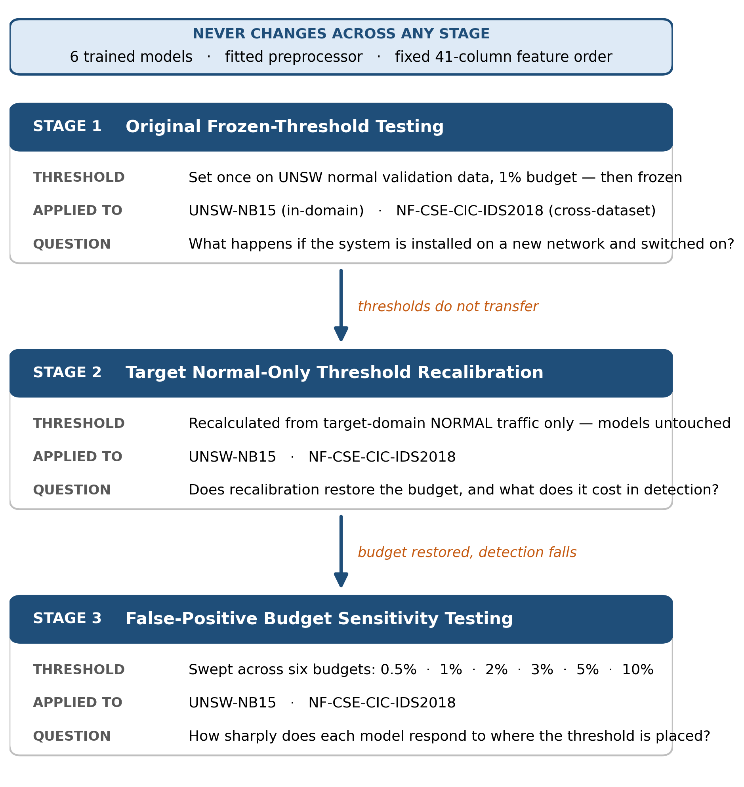
Figure 1. The three-stage testing framework. Models, preprocessor and feature order stay frozen; only the threshold changes.
Stage | What changes | Question it answers
1 — Original frozen-threshold testing | Nothing. The UNSW threshold is applied unchanged to both domains. | What happens if the system is installed on a new network and switched on?
2 — Target normal-only recalibration | The threshold is recalculated from NF-CSE normal traffic. | Does recalibration fix the false positives, and what does it cost?
3 — Parameter sensitivity | The budget is swept across six values from 0.5% to 10%. | How sharply does each model respond to where the threshold is placed?

The order matters. Stage 1 has to come first because it is the honest baseline — the no-recalibration case. Without it, Stage 2 would have nothing to be measured against. Stage 3 then tests whether Stage 2’s single operating point was a lucky choice or a stable one.
The three-stage sequence above defines what is tested. The following framework defines how threshold decisions are interpreted, controlled and reproduced across those stages. It is deliberately decision-layer focused: the model and preprocessing pipeline stay fixed while the alert boundary is examined as a separate engineering object.

8.1 Why Threshold Evaluation Is Separate from Model Training
Each detector produces a continuous anomaly score before it produces an alert. Model training determines the score geometry and ordering; the threshold determines how aggressively those scores are converted into normal/anomalous decisions. Changing the threshold can therefore change precision, recall, F1 and FPR even though the learned model has not changed. Treating the two layers separately is necessary if a performance change is to be attributed correctly.
Decision rule: anomaly if s(x) ≥ τ ; otherwise normal
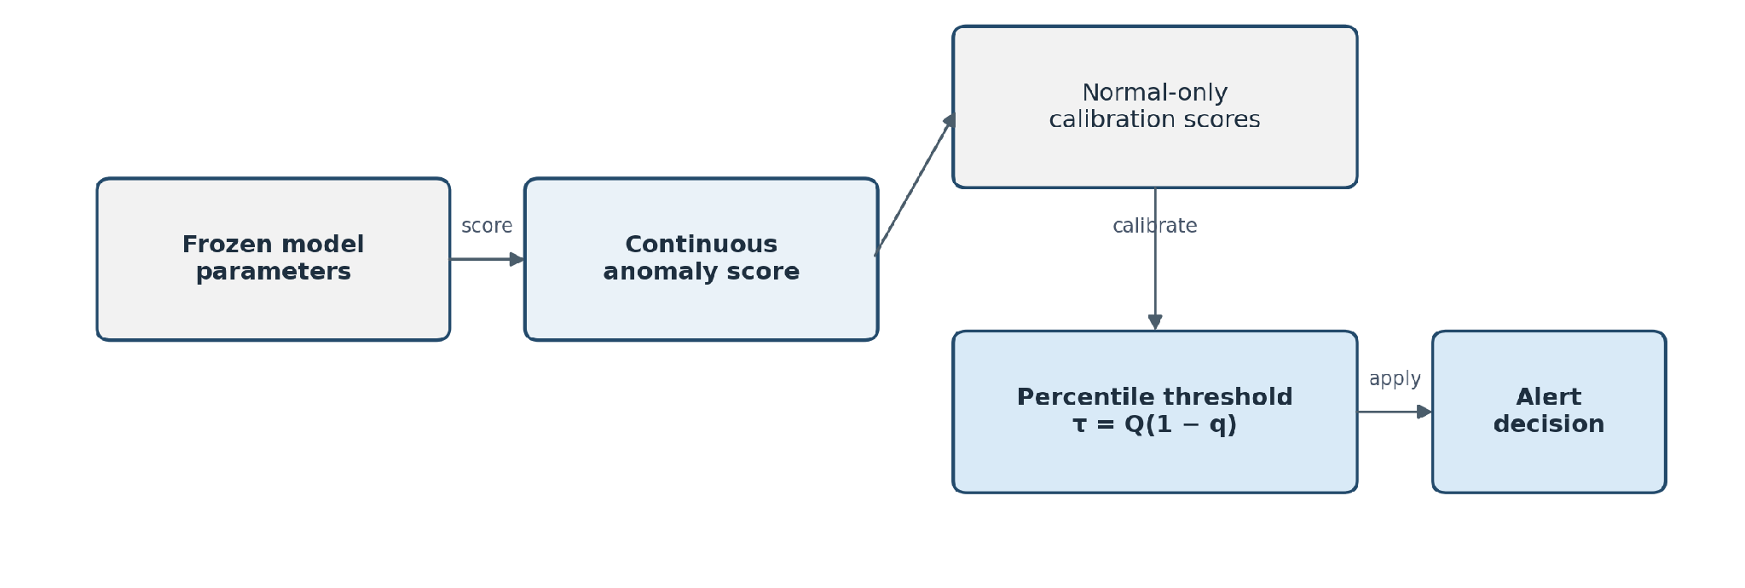
Figure 1A. Separation of frozen model scoring from normal-only decision-threshold calibration.

8.2 Why Frozen Models Are Required for Fair Comparison
During threshold experiments, all six saved model artefacts and the fitted preprocessing contract remain frozen. If the model were retrained while the threshold was also changed, any improvement or degradation could come from either source and the experiment would no longer isolate the decision layer. The frozen-model design therefore creates a controlled comparison: the score vector for a given model/domain is fixed, and the only variable is the cut-off applied to that score vector.
This is also why ROC-AUC and PR-AUC should remain constant across threshold budgets for the same frozen score set. A change in those ranking metrics would indicate that something other than the threshold changed and should be treated as an implementation or provenance failure.

8.3 Evaluation Questions and Acceptance Criteria
ID | Evaluation question | Why it matters
EQ-01 | Do source-domain thresholds remain usable on unseen traffic? | Tests threshold transfer independently of retraining.
EQ-02 | Can normal-only target recalibration reduce false positives? | Tests whether the decision layer can adapt without changing model weights.
EQ-03 | How sensitive is each detector to threshold placement? | Reveals whether a useful operating region exists or whether small changes cause instability.
EQ-04 | Is one threshold budget appropriate for all models? | Checks whether model-specific score distributions require different operating points.

Criterion | Required evidence
Same evaluation logic | All six detectors use the same confusion-matrix definitions and metric formulas.
No retraining during threshold analysis | Model files and fitted preprocessor remain unchanged.
Leakage-free calibration | Calibration records are excluded from held-out test records.
Normal-only threshold selection | Attack labels are never used to place the threshold.
Explicit false-positive reporting | FPR and false alerts per 1,000 normal records are reported with detection metrics.
Negative results preserved | Collapsed thresholds, inverted ranking, score ties and budget failures remain in the analysis.

8.4 Operating-Point Metrics versus Ranking Metrics
Section 7 defines every metric in detail. For threshold analysis, the important additional distinction is whether a metric depends on the selected operating point. Precision, recall, F1 and FPR change when τ moves. ROC-AUC and PR-AUC are calculated from score ordering across thresholds and therefore describe ranking quality rather than one specific alert policy. Reading both layers together prevents two different failures from being confused.
Metric layer | Measures | Threshold dependent? | Main diagnostic use
Operating point | Precision, Recall, F1, FPR | Yes | Shows what the analyst experiences at the chosen cut-off.
Ranking quality | ROC-AUC, PR-AUC | No | Shows whether attacks and normal records remain usefully ordered before the cut-off is chosen.
Confusion matrix | TP, TN, FP, FN | Yes | Exposes collapse that percentages can hide and verifies record totals.
A model can therefore have a useful ROC-AUC but an unusable FPR if its threshold is misplaced. Conversely, a new threshold cannot rescue a detector whose attack and normal scores are fundamentally intermingled or inverted. This distinction is central to the interpretation of the NF-CSE results.

8.5 Normal-Only Percentile Calibration Methodology
Thresholds are selected from normal scores only. Let S = {s1, s2, …, sn} be the scores produced by a frozen model for n normal calibration records and let q be the requested upper-tail budget. The threshold is the empirical (1−q) quantile of S. A 1% budget therefore uses approximately the 99th percentile of normal scores.
τq = Q(1 − q)(S) | 1% budget ⇒ τ ≈ 99th percentile of normal scores
The percentile budget is a calibration target, not a promise about unseen traffic. By construction, the selected threshold reproduces its requested tail rate on the calibration sample, subject to score ties and quantile behaviour. Held-out FPR can differ whenever the normal-score distribution shifts. The report therefore keeps the requested budget and realised held-out FPR as separate quantities.
Provenance field | What must be recorded
Model identity | Detector name and saved model/version used for scoring
Preprocessing contract | Saved preprocessor and fixed 41-column feature order
Calibration source | Dataset/partition and normal-record count used to compute τ
Requested budget | 0.5%, 1%, 2%, 3%, 5% or 10%
Threshold value | Exact numeric cut-off produced for that model and budget
Evaluation set | Held-out dataset/partition used after τ was fixed
Run evidence | Threshold JSON/configuration, metrics file and record-level outputs where available

8.6 Threshold-Sensitivity Methodology
One operating point is insufficient to characterise a detector. The NF-CSE analysis therefore sweeps six normal-tail budgets: 0.5%, 1%, 2%, 3%, 5% and 10%. For a given model/domain, the score vector is calculated once and reused. Only τ changes between budgets. This makes the sensitivity curve a property of the decision rule rather than a sequence of separately tuned models.
Control | Methodological requirement
Frozen scores | The same held-out score vector is used at every budget.
Only τ changes | No model fitting, preprocessor fitting or feature-order change is allowed.
Same held-out records | Every budget is evaluated on the identical test set.
Ranking metrics fixed | ROC-AUC and PR-AUC should remain constant across budgets.
Per-model interpretation | Sensitivity is assessed separately because score scale, density and ties differ by model.
Ties/saturation checked | Repeated thresholds or abrupt jumps are treated as score-resolution issues, not smooth trade-offs.

8.7 Calibration/Test Separation and Leakage Prevention
A threshold result is only defensible when the records used to select τ are separate from the records used to claim final performance. Using the same normal records to place the cut-off and then report FPR would make the result optimistic. Using attack labels to select τ would leak knowledge of the test attacks into the decision rule.
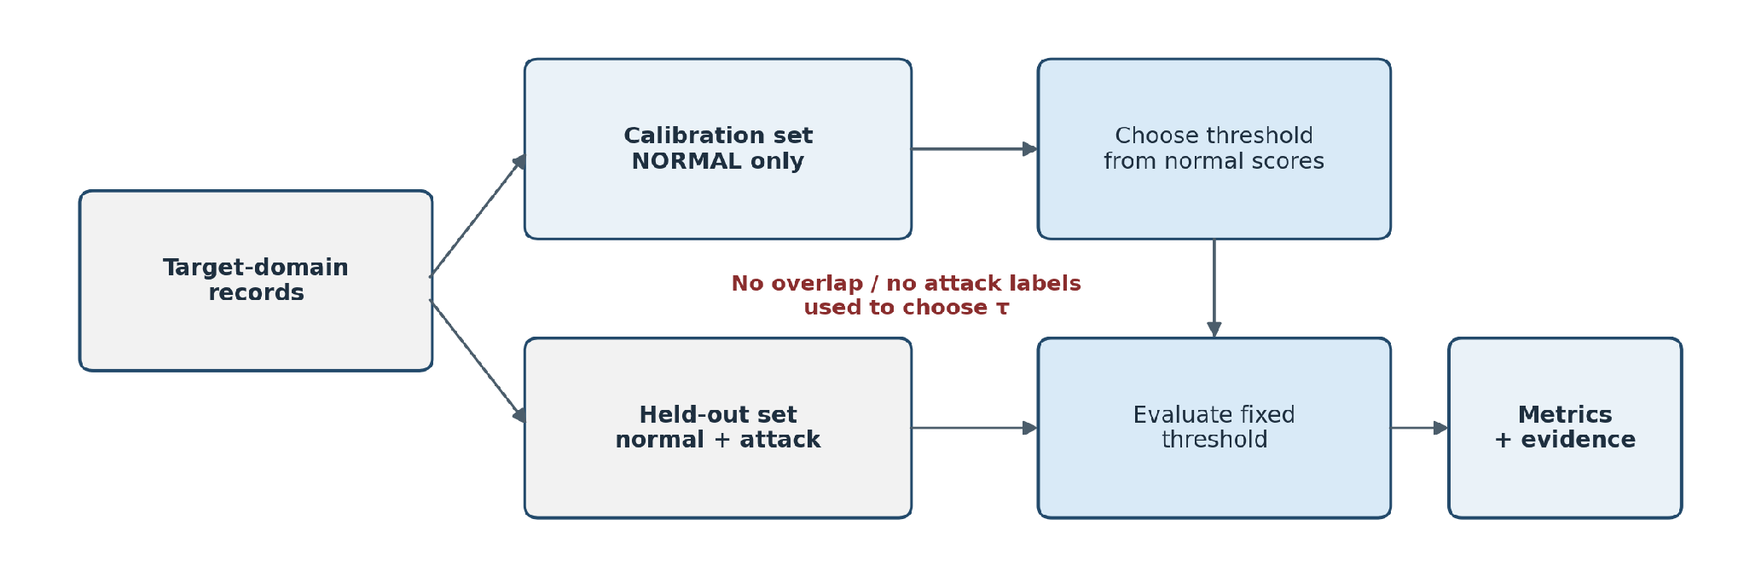
Figure 1B. Calibration/test separation used to prevent threshold-selection leakage.
Control | Rule used in this report
Calibration class | Normal records only.
Calibration/test overlap | Zero overlap is required.
Attack labels | Used only after prediction for evaluation, never for choosing τ.
Held-out metrics | Calculated only after the threshold is fixed.
Recalibration | Creates a new threshold record; it does not overwrite the evidence for the previous run.
For NF-CSE, the recalibration design uses 100,000 normal records for threshold selection and a separate 600,000-record held-out set for final evaluation. This split is central to the interpretation of Stage 2 because it prevents the reported post-calibration metrics from being properties of the same records that defined the cut-off.
Result-file reconciliation (supplied evaluation exports). Stage 1 NF-CSE results in NF_CSE_1pct_Model_Comparison.csv cover 700,000 records (400,000 normal; 300,000 attack). The Stage 2 recalibrated export NF_CSE_Recalibrated_1pct_Model_Comparison.csv covers 600,000 held-out records (300,000 normal; 300,000 attack), after 100,000 target-normal records were reserved for calibration. The original source-threshold and recalibrated results therefore do not share identical evaluation denominators. Rate comparisons are descriptive; an exact paired evaluation of threshold-only changes would require predictions on the same held-out records with both thresholds. The exports provide aggregate counts, but do not by themselves establish the exact split-generation code or independence of similar/duplicate flow records.

8.8 Formal Threats to Validity
Validity area | Threat | Effect on interpretation | Response
Internal validity | Calibration and held-out normal distributions may differ. | The requested budget may not equal the FPR. | Keep sets separate and report measured FPR, not only the budget.
Construct validity | Attack-heavy test sets can make recall/F1 look strong while normal traffic is over-flagged. | A collapsed detector may appear acceptable. | Interpret FPR, false alerts/1,000 and confusion matrices alongside F1.
External validity | UNSW-NB15 and NF-CSE are benchmark datasets rather than a live SME network. | No threshold is a production guarantee. | Treat operating points as environment-specific and revalidate on representative normal traffic.
Implementation validity | Tied or saturated anomaly scores can make percentile thresholds unstable. | Several budgets may map to the same cut-off or cause abrupt jumps. | Inspect score resolution and do not assume smooth sensitivity.
Reproducibility | One fixed seed and finite exported evidence do not measure run-to-run variance. | Results are reproducible but uncertainty across alternative splits is not fully quantified. | Retain seed/configuration and add multi-seed validation in future work.

8.10 Threshold Governance, Drift Monitoring and Change Control
Threshold calibration should not be treated as a one-time notebook action. In a deployment-oriented design, the threshold is security configuration with an owner, provenance, approval state and review trigger. A change in τ changes alert behaviour even when the model is untouched, so the change should be reviewable and reversible.
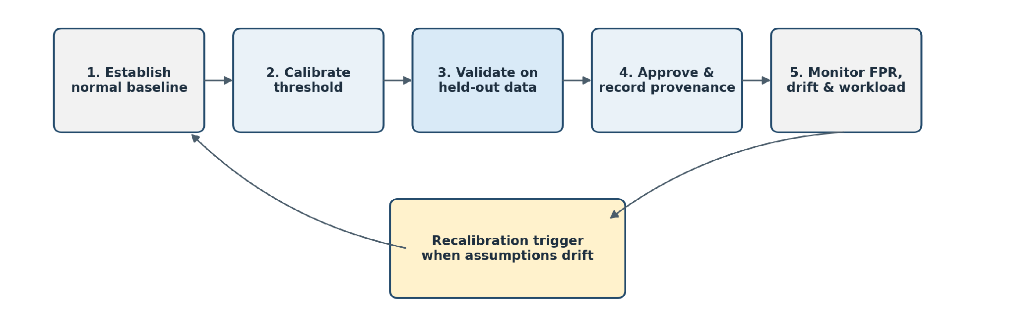
Figure 1C. Recommended threshold-governance lifecycle for deployment-oriented use.
Recalibration should be triggered by evidence that the normal-score distribution or operational workload has changed, for example sustained growth in analyst-confirmed false alerts, a major service or software change, a shift in normal score quantiles, or a material change in traffic volume. The trigger should start a controlled recalibration process rather than silently moving the threshold.
Governance step | Required action
Baseline | Establish representative normal traffic and save the model/preprocessor identifiers.
Calibrate | Compute τ from normal scores for a stated budget and record exact provenance.
Validate | Apply τ to independent held-out data and compare realised FPR with the requested budget.
Approve | Record reviewer, reason for change, date and accepted operating point.
Monitor | Track false-alert workload, score-distribution drift and material network changes.
Rollback | Retain the previous approved threshold so unstable changes can be reversed.

9. Original Threshold Configuration

9.1 Threshold Configuration Overview
A one-class model outputs a score, not a decision. The threshold turns the score into an alert, and it is not part of the trained model — it is a separate number taken from data. Every threshold used in Stage 1 was set once from the UNSW normal validation records, then frozen and applied unchanged to both domains.

9.2 Normal Validation Score Distribution
Each model scored all 10,266 normal validation records. These scores define what normal looks like to that model, and every threshold is read off this distribution.
Model | Normal median | Normal 99th pct | Scale
Isolation Forest | 0.3969 | 0.6317 | 0 to 1
Dense Autoencoder | 0.0029 | 0.1255 | Reconstruction error
Hybrid IF+AE | 0.5609 | 0.9993 | 0 to 1, compressed
LOF | 1.0929 | 2.8653 | Unbounded above
One-Class SVM | −5.6506 | 2.0008 | Signed distance
Deep SVDD | 0.000005 | 0.000259 | Squared distance

The scales are completely different, so thresholds cannot be compared between models — only within one. The 99th-percentile column is what the 1% budget selects.

9.3 Original 1% Validation FPR Budget
I fixed the budget at 1% of normal traffic before calculating anything. It is an operational ceiling, not a tuning target: an SME team can absorb roughly 10 false alerts per 1,000 records, not 50. The budget comes from what the client can process, not from what makes the models look best. Thresholds at 0.5% and 3% were calculated at the same time for the Stage 3 work.

9.4 Percentile-Based Threshold Calculation
threshold = np.percentile(val_normal_scores, 100 − budget_pct)
For a 1% budget that is the 99th percentile. By construction, 1% of the validation records fall above it.
The assumption built into that one line is that new traffic will have the same score distribution as the calibration sample. Stage 1 tests that assumption directly.

9.5 Model-Specific Thresholds
Model | 0.5% budget | 1% budget (Stage 1) | 3% budget
Isolation Forest | 0.567650 | 0.546054 | 0.496639
Dense Autoencoder | 0.045774 | 0.036468 | 0.023754
Hybrid IF+AE | 0.990994 | 0.980082 | 0.938938
LOF | 1.982746 | 1.800995 | 1.476140
One-Class SVM | 0.715225 | −0.000053 | −1.091460
Deep SVDD | 0.000081 | 0.000055 | 0.000031

One-Class SVM’s 1% threshold is slightly negative and Deep SVDD’s is 0.000055. Neither means anything on its own — both are meaningful only against their own model’s distribution. The 1% column is what Stage 1 applied to both domains.

9.6 Threshold Storage and Reuse
Every threshold is written to config/threshold_config.json with the budget that produced it and the number of calibration records used. Stage 1 loads these values rather than recomputing them, which guarantees the same number reaches both domains and leaves one file as the record of what was applied.

9.7 Threshold Verification
Check | Expected | Result
Thresholds stored for all six models | 6 | 6
Each reproduces its budget on the calibration data | ~1% | ~1%
Attack labels used in the calculation | No | No
Calibration records counted | 10,266 | 10,266
Same value applied to both domains | Yes | Yes

The second row looks reassuring and is not. A threshold measured on the records it was calculated from will always reproduce its budget. That is arithmetic, not evidence. What matters is what the same threshold does on records it has not seen — which is Section 11.

10. Stage 1 — Original Frozen-Threshold Testing

10.1 Objective of Stage 1
Stage 1 answers the no-recalibration question: if the system were installed on a new network and simply switched on, what would happen? Nothing is adjusted. This is the honest baseline that Stages 2 and 3 are measured against.

10.2 Experimental Setup
Model | Score it produces
Isolation Forest | How easily a record is separated from the rest
Dense Autoencoder | Reconstruction error — how badly the record rebuilds
Hybrid IF+AE | A combination of the two scores above
LOF | Local density compared with neighbours
One-Class SVM | Signed distance from the learned boundary
Deep SVDD | Distance from the centre of a learned sphere

Domain | Records | Normal | Attack
UNSW-NB15 (in-domain) | 82,332 | 37,000 | 45,332
NF-CSE-CIC-IDS2018 (cross-dataset) | 700,000 | 400,000 | 300,000

10.3 Frozen Model Configuration
All six model files were loaded from disk and used exactly as the modelling workstream supplied them. No model was retrained, refitted or tuned. If a model had changed between stages, a difference in results could come from the model or the threshold, and I could not tell which.

10.4 Frozen Preprocessor Configuration
The fitted preprocessor was loaded from models/preprocessor.joblib and applied to both domains. It was never refitted. The 41-column order was read from feature_order.json and verified before scoring — a silent column mismatch would make a model read duration where it expects byte count, with no error raised.

10.5 Frozen Original Thresholds
Thresholds were loaded from config/threshold_config.json at the 1% budget. The values are in Section 9.5. The same number was applied to UNSW and to NF-CSE.

10.6 UNSW-NB15 Original Testing
The in-domain case: 82,332 records from the official testing partition. The traffic comes from the same dataset the models trained on, so this is the most favourable condition any of them will face. Whatever happens here is the ceiling.

10.7 External-Domain Original Testing
NF-CSE-CIC-IDS2018 — 700,000 records from a different capture on a different network, processed into the same 41 columns. This tests whether a threshold built on one benchmark means anything on another.

10.8 Test Prediction Procedure
prediction = (score > threshold).astype(int)
One line, applied identically in both domains. No per-domain adjustment of any kind.

10.9 Result Collection
For every model and domain I recorded precision, recall, F1, FPR, false alerts per 1,000, ROC-AUC, PR-AUC and the full confusion matrix. Separating the threshold-dependent metrics from the threshold-independent ones is the point: a model can keep a usable ROC-AUC while its fixed threshold lands in the wrong place.
Record-level scores and predictions were exported for both domains, so any figure in Section 11 can be recomputed without re-running a model.

10.10 Stage 1 Verification
Check | Expected | Result
Models loaded, not retrained | 6 loaded | 6 loaded
Preprocessor refitted at any point | No | No
Column count and order | 41, matching | Confirmed
Same threshold applied to both domains | Yes | Yes
Confusion matrix totals match record counts | Match | 82,332 / 700,000

One verification result shapes the next section. On NF-CSE, four of the six models returned TN = 0 and FN = 0 — they flagged all 700,000 records. That is not a reporting error; the threshold sits below the entire score range in that domain.

11. Stage 1 Results

11.1 UNSW-NB15 Results
In-domain, 82,332 records, 1% budget.
Model | Precision | Recall | F1 | FPR (%) | Alerts/1k | ROC-AUC | PR-AUC
Dense Autoencoder | 0.936 | 0.633 | 0.755 | 5.27 | 52.7 | 0.879 | 0.901
Hybrid IF+AE | 0.944 | 0.626 | 0.753 | 4.55 | 45.5 | 0.877 | 0.906
Isolation Forest | 0.940 | 0.617 | 0.745 | 4.82 | 48.2 | 0.851 | 0.897
Deep SVDD | 0.927 | 0.595 | 0.725 | 5.70 | 57.0 | 0.887 | 0.896
LOF | 0.936 | 0.523 | 0.671 | 4.35 | 43.5 | 0.898 | 0.889
One-Class SVM | 0.894 | 0.340 | 0.492 | 4.94 | 49.4 | 0.794 | 0.838

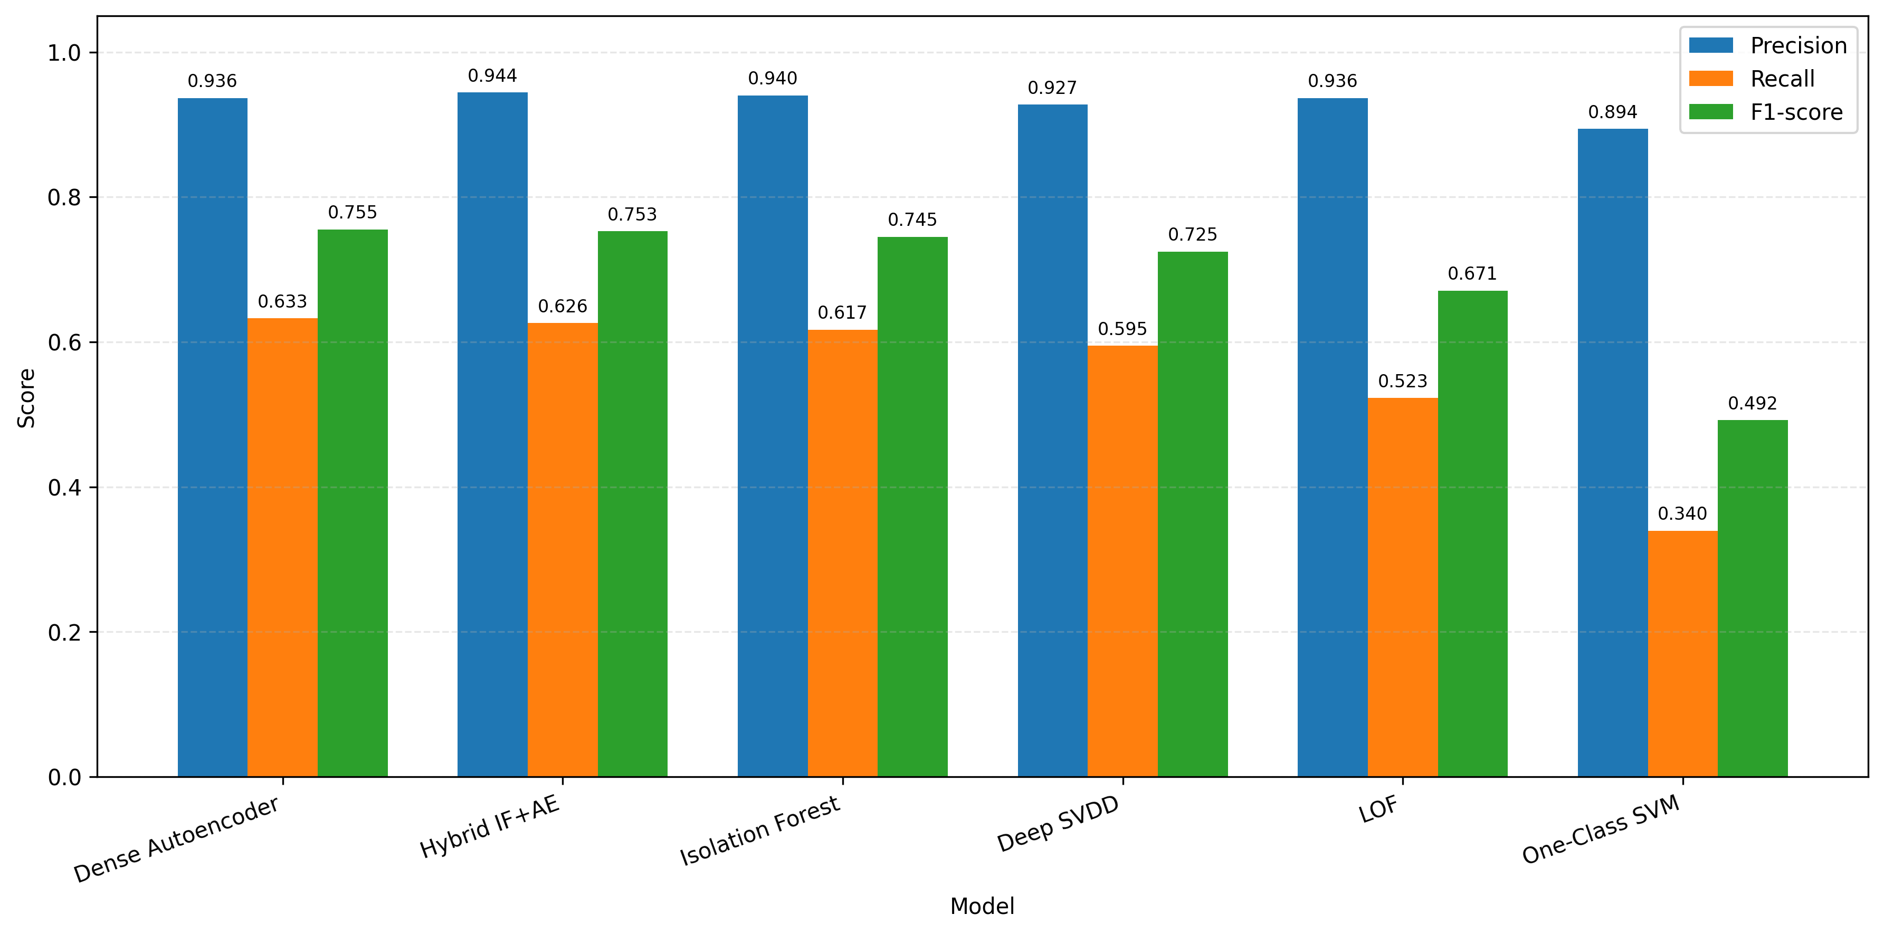
Figure 1D. UNSW-NB15 source-domain precision, recall and F1-score at the 1% validation-budget operating point (project-generated result).

11.2 Original External-Domain Results
NF-CSE-CIC-IDS2018, 700,000 records, same thresholds.
Model | Precision | Recall | F1 | FPR (%) | Alerts/1k | ROC-AUC | PR-AUC
LOF | 0.445 | 0.996 | 0.615 | 93.30 | 933.0 | 0.569 | 0.435
Isolation Forest | 0.444 | 0.997 | 0.614 | 93.67 | 936.7 | 0.464 | 0.379
Dense Autoencoder | 0.429 | 1.000 | 0.600 | 100.00 | 1000.0 | 0.126 | 0.297
Hybrid IF+AE | 0.429 | 1.000 | 0.600 | 100.00 | 1000.0 | 0.286 | 0.319
One-Class SVM | 0.429 | 1.000 | 0.600 | 100.00 | 1000.0 | 0.889 | 0.913
Deep SVDD | 0.429 | 1.000 | 0.600 | 100.00 | 1000.0 | 0.843 | 0.739

Four models returned TN = 0 and FN = 0. The recall of 1.000 is meaningless — a detector that says “attack” to everything scores perfect recall.
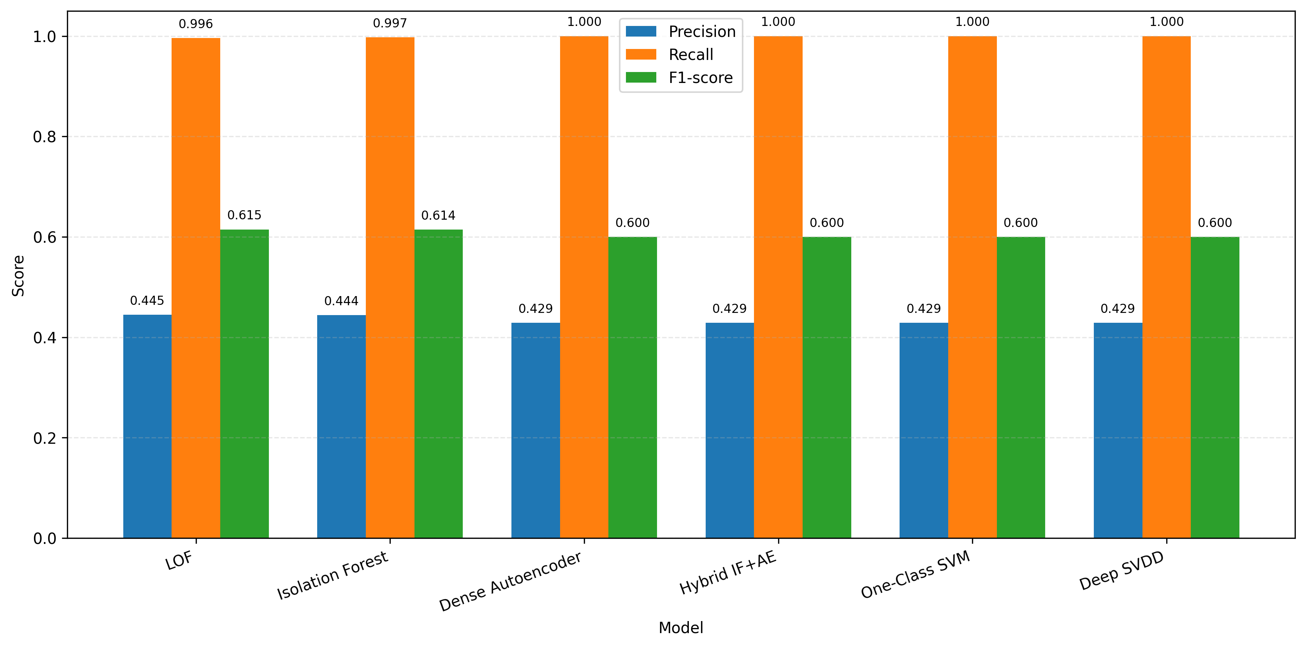
Figure 1E. NF-CSE-CIC-IDS2018 precision, recall and F1-score using the unchanged UNSW source-domain thresholds (project-generated result).

11.3 Six-Model Performance Comparison
Model | UNSW F1 | NF-CSE F1 | UNSW FPR | NF-CSE FPR
Dense Autoencoder | 0.755 | 0.600 | 5.27% | 100%
Hybrid IF+AE | 0.753 | 0.600 | 4.55% | 100%
Isolation Forest | 0.745 | 0.614 | 4.82% | 93.67%
Deep SVDD | 0.725 | 0.600 | 5.70% | 100%
LOF | 0.671 | 0.615 | 4.35% | 93.30%
One-Class SVM | 0.492 | 0.600 | 4.94% | 100%

The NF-CSE F1 column looks almost flat at 0.600, which is misleading. That figure comes from flagging everything in a set that is 43% attacks. F1 is unreliable here, which is why the FPR columns carry the real message.

11.4 False-Positive Results
Domain | Budget promised | Measured range | Over-run
UNSW (in-domain) | 10 per 1,000 | 43 – 57 | 4× – 6×
NF-CSE | 10 per 1,000 | 933 – 1,000 | 93× – 100×

On NF-CSE the best model still raises 933 false alerts in every 1,000 records. The system is not degraded; it has stopped working as a filter.
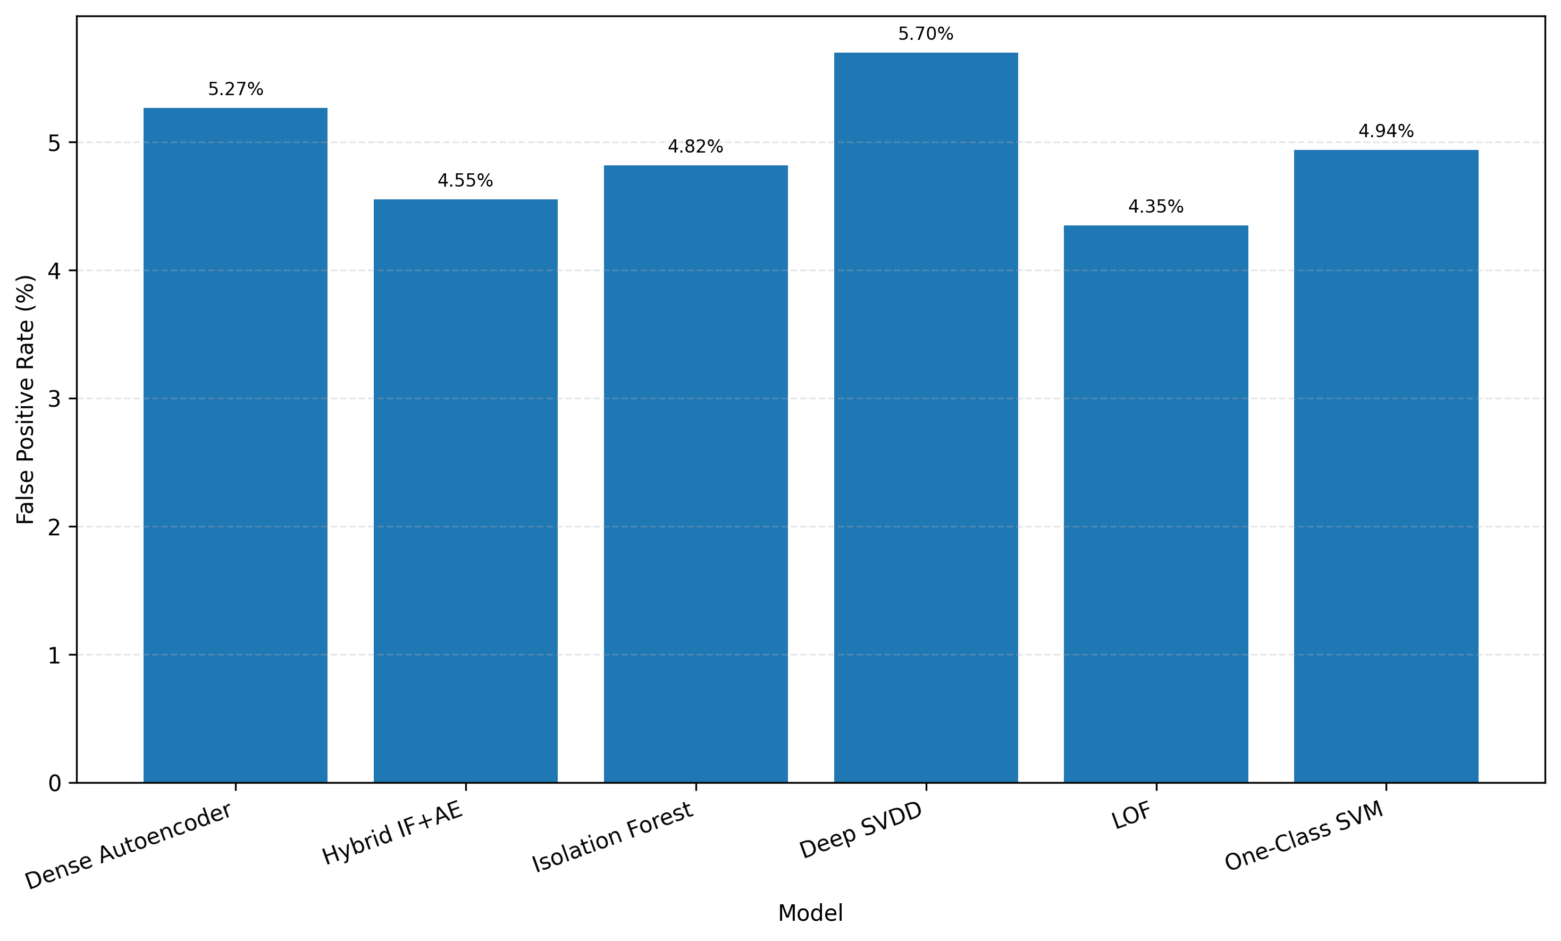
Figure 1F. UNSW-NB15 realised false-positive rate by model at the 1% validation-budget operating point (project-generated result).

11.5 Recall Results
UNSW recall runs 0.340 to 0.633 — modest but genuine detection. NF-CSE recall runs 0.996 to 1.000, which is the artefact of flagging everything.
Recall rising as a model moves to an unfamiliar domain is the clearest sign the threshold has collapsed. Detection did not improve; the threshold simply fell below the entire score range.

11.6 F1-Score Results
Best in-domain F1 is Dense Autoencoder at 0.755, with Hybrid and Isolation Forest close behind. One-Class SVM is well behind at 0.492, held back by recall of 0.340. Externally, F1 is not usable as a ranking metric for the class-balance reason above.

11.7 ROC-AUC Results
ROC-AUC does not depend on the threshold, so it isolates whether ranking survived.
Model | UNSW | NF-CSE
LOF | 0.898 | 0.569
Deep SVDD | 0.887 | 0.843
Dense Autoencoder | 0.879 | 0.126
Hybrid IF+AE | 0.877 | 0.286
Isolation Forest | 0.851 | 0.464
One-Class SVM | 0.794 | 0.889

- One-Class SVM improved on NF-CSE — 0.794 in-domain, 0.889 cross-domain. Its ranking transferred well even though its threshold failed at 100% FPR. This is the clearest proof that model transfer and threshold transfer are separate problems.
- Dense Autoencoder scored 0.126. Below 0.5 means the ranking is inverted — it scores attacks as more normal than normal traffic. This needs investigation before the model is trusted anywhere.
- Isolation Forest at 0.464 is effectively random on NF-CSE.

11.8 PR-AUC Results
PR-AUC follows the same pattern. One-Class SVM leads on NF-CSE at 0.913 and Deep SVDD follows at 0.739, while Dense Autoencoder (0.297) and Hybrid (0.319) sit near the bottom. In-domain all six cluster between 0.838 and 0.906, which again shows how little in-domain figures predict.

11.9 Confusion-Matrix Analysis
UNSW — Dense Autoencoder (best in-domain F1):
 | Predicted normal | Predicted attack
Actually normal | 35,051 | 1,949
Actually attack | 16,650 | 28,682

1,949 false alarms, and 16,650 attacks missed. Even at its best, the system misses 37% of attacks.
NF-CSE — Dense Autoencoder (total collapse):
 | Predicted normal | Predicted attack
Actually normal | 0 | 400,000
Actually attack | 0 | 300,000

An entirely empty “predicted normal” column. The threshold sits below every score in the domain. Isolation Forest is the partial case: 25,316 true negatives out of 400,000, which is 93.67% FPR — not total, but no more deployable.

11.10 Stage 1 Findings
F1. The 1% budget never held. 4.35–5.70% in-domain, 93.3–100% on NF-CSE.
F2. Four of six models completely collapsed on NF-CSE, flagging all 700,000 records.
F3. Model transfer and threshold transfer are different failures. One-Class SVM’s ROC-AUC rose to 0.889 while its threshold produced 100% false positives.
F4. High recall and F1 in the external domain are artefacts of threshold collapse plus class imbalance, not evidence of detection.
F5. Dense Autoencoder’s NF-CSE ROC-AUC of 0.126 indicates inverted scoring and needs investigation.
This result establishes a serious threshold-transfer failure but does not rule out underlying model-ranking problems. Stage 2 tests which components of performance can be recovered through target-normal recalibration alone.

12. Original Threshold Transfer Analysis

12.1 In-Domain vs Target-Domain Behaviour
Model | UNSW FPR | NF-CSE FPR
Isolation Forest | 4.82% | 93.67%
Dense Autoencoder | 5.27% | 100%
Hybrid IF+AE | 4.55% | 100%
LOF | 4.35% | 93.30%
One-Class SVM | 4.94% | 100%
Deep SVDD | 5.70% | 100%

In-domain the threshold is wrong by a factor of five. Cross-domain it is wrong by a factor of 93 to 100. The failure is not a cliff at the domain boundary — it is already present at home and becomes total away from it.

12.2 Changes in Anomaly Score Distribution
On UNSW the threshold sits where a 1% budget should put it, in the upper tail of the normal scores:
Model | Normal median | Normal 99th pct | Threshold
Isolation Forest | 0.3969 | 0.6317 | 0.546054
Dense Autoencoder | 0.0029 | 0.1255 | 0.036468
Hybrid IF+AE | 0.5609 | 0.9993 | 0.980082
Deep SVDD | 0.000005 | 0.000259 | 0.000055

On NF-CSE it does not. There is no record-level export for that domain, but the false-positive counts answer the question exactly: for the four models at 100% FPR, all 400,000 normal records scored above the threshold. The entire normal distribution has moved past it.

12.3 Threshold Transfer Failure
The size of the error shows in how far each threshold had to move when recalibrated on NF-CSE normal traffic in Stage 2:
Model | Original (UNSW) | Recalibrated (NF-CSE) | Factor
Isolation Forest | 0.546054 | 0.691877 | 1.3×
Dense Autoencoder | 0.036468 | 0.450272 | 12×
Hybrid IF+AE | 0.980082 | 0.999903 | 1.02×
LOF | 1.800995 | 8.336277 | 4.6×
One-Class SVM | −0.000053 | 19.434098 | sign change
Deep SVDD | 0.000055 | 0.023528 | 428×

A threshold calculated on the target domain is a different number entirely. Deep SVDD’s is 428 times larger; One-Class SVM’s moves from marginally negative to +19.4. The original value is not approximately right.

12.4 False-Positive Inflation
At 933 alerts per 1,000 records, an analyst reviewing NF-CSE traffic would open almost every flow on the network and find that roughly 55% of what they open is a false alarm. The in-domain case is less dramatic but still four to six times the budget — 4,350 to 5,700 false alerts a day on a network carrying 100,000 flows.

12.5 Model-Specific Transfer Behaviour
Pattern A — complete collapse. Dense Autoencoder, Hybrid, One-Class SVM and Deep SVDD on NF-CSE. Every record flagged.
Pattern B — partial collapse. Isolation Forest (93.67%) and LOF (93.30%). A small normal region survived, but not a usable one.
Pattern C — ranking survives, threshold does not. One-Class SVM is the important case. Its ROC-AUC rose to 0.889 and its PR-AUC to 0.913 — the best cross-domain ranking of any model — while its threshold produced 100% false positives.
Pattern C is the central result here. The model still separates attacks from normal traffic correctly. Only the cut-point is wrong. Had I reported ROC-AUC alone, One-Class SVM would have looked like the strongest cross-domain model and the 100% false-positive rate would never have appeared.
One counter-case: the Dense Autoencoder’s ROC-AUC of 0.126 is below 0.5, so its ranking is inverted on NF-CSE. That is a model failure, not a threshold failure, and no threshold can repair it.

12.6 Evidence of Domain Shift
1. Within UNSW itself — a threshold giving 1% on validation gave 2.13% on the test partition, and six of 41 columns had shifted between them.
2. The six models’ measured in-domain FPR of 4.35–5.70% against a 1% budget, on data from the same dataset.
3. All 400,000 NF-CSE normal records scored above the threshold for four models.
4. Recalibrated thresholds differing from the originals by up to 428 times.
Point 1 is the most uncomfortable. If a threshold does not hold between two partitions of one dataset, prepared by the same pipeline, it will not hold on a production network over time.

12.7 Need for Target-Domain Recalibration
- The models are not the problem. One-Class SVM improved its ranking cross-domain, and Deep SVDD kept ROC-AUC 0.843. The ranking transferred; the decision rule did not.
- A threshold is a property of the traffic it was measured on, not of the model. It cannot be shipped with the model.
- Recalibration must use target-domain normal traffic and no labels, because a deployed network supplies normal traffic freely and labels not at all.
That defines Stage 2: hold every model frozen, recalculate the threshold from normal traffic in the target domain, and measure what is restored and what is lost.

13. Stage 2 — Normal-Only Threshold Recalibration

13.1 Objective of Stage 2
Stage 1 showed that source-domain thresholds failed on the external test population. This alone cannot establish that the learned model ranking is adequate. Stage 2 recalculates thresholds from target-domain normal traffic without retraining and measures whether acceptable false-positive rates and attack separation can both be recovered.

13.2 Why Models Remained Frozen

No model was retrained, refitted or tuned in Stage 2. Only the thresholds changed.
If a model had changed, a difference between Stage 1 and Stage 2 could come from either the model or the threshold. Holding the models fixed attributes every change to the threshold alone.

13.3 Target Normal-Only Calibration Principle
The threshold is calculated from normal traffic in the domain where the system will run. Only normal records are used, because a deployed network supplies normal traffic freely and attack labels not at all. A method that needs labels cannot be repeated in practice.

13.4 Calibration Dataset Selection
Domain | Calibration normals | Held-out test records | Composition
NF-CSE-CIC-IDS2018 | 100,000 | 600,000 | 300,000 normal, 300,000 attack

Stage 2 was not run on UNSW-NB15, and this is deliberate. UNSW is the calibration domain — the original thresholds were already calculated from UNSW normal validation records. Recalibrating on UNSW would mean recomputing the same percentile from the same source and arriving at the same number. There is nothing to recalibrate to.
The in-domain equivalent of this test is the parameter sweep in Section 16, which does vary the UNSW threshold and measures the effect.

13.5 Separation of Calibration and Test Data
None of the 100,000 calibration records appears in the 600,000 held-out test records. A threshold measured on its own calibration data reproduces its budget almost exactly and tells us nothing about new traffic.

13.6 Exclusion of Attack Labels from Threshold Selection
Attack labels took no part in choosing any threshold. They were read only after predictions were produced, to score the results. A threshold swept until F1 looks best on labelled data cannot be reproduced on a live network.

13.7 Recalibrated Threshold Calculation
The same percentile rule as Stage 1, applied to NF-CSE normal scores. Thresholds were calculated at 0.5%, 1% and 3% and saved to JSON with the calibration record count. The 1% budget is the reported operating point.

13.8 Threshold Application
Each held-out record is scored by the frozen model and compared with its new threshold, using the same one-line rule as Stage 1.

13.9 Held-Out Testing
Predictions were produced on the held-out records only and scored with the same seven metrics as Stage 1. ROC-AUC and PR-AUC are unchanged from Stage 1, because the models and their rankings did not change — only the cut-point did.

13.10 Stage 2 Verification
Check | Expected | Result
Models retrained or refitted | No | No
Preprocessor refitted | No | No
Attack labels used in threshold calculation | No | No
Calibration records overlapping test records | 0 | 0
Thresholds recalculated for all six models | 6 | 6
ROC-AUC unchanged from Stage 1 | Unchanged | Unchanged

The last row is the strongest evidence the models were untouched. A retrained model would rank differently and produce a different ROC-AUC.

14. Stage 2 Recalibration Results
NF-CSE-CIC-IDS2018, 600,000 held-out records (300,000 normal, 300,000 attack), calibration records excluded.

14.1 Recalibrated Thresholds
Model | Original (UNSW) | Recalibrated (NF-CSE)
Isolation Forest | 0.546054 | 0.691877
Dense Autoencoder | 0.036468 | 0.450272
Hybrid IF+AE | 0.980082 | 0.999903
LOF | 1.800995 | 8.336277
One-Class SVM | −0.000053 | 19.434098
Deep SVDD | 0.000055 | 0.023528

Every threshold rose, several of them by orders of magnitude.

14.2 Precision Results
Model | Precision | Change from Stage 1
One-Class SVM | 0.988 | +0.559
Deep SVDD | 0.711 | +0.282
LOF | 0.656 | +0.211
Isolation Forest | 0.468 | +0.024
Dense Autoencoder | 0.467 | +0.038
Hybrid IF+AE | 0.289 | −0.140

Precision rose because the thresholds are now very strict — few alerts, and most of them correct. The cost shows up in recall.

14.3 Recall Results
Model | Recall | Attacks found of 300,000
One-Class SVM | 0.819 | 245,771
Deep SVDD | 0.027 | 8,100
LOF | 0.020 | 6,000
Hybrid IF+AE | 0.011 | 3,300
Isolation Forest | 0.009 | 2,721
Dense Autoencoder | 0.009 | 2,700

This is the central Stage 2 result. Five of six models fell below recall 0.027 — they detect under 3% of attacks. Isolation Forest found 2,721 of 300,000. One-Class SVM is the sole exception at 0.819.

14.4 F1-Score Results
One-Class SVM 0.896; Deep SVDD 0.051; LOF 0.038; Hybrid 0.021; Isolation Forest and Dense Autoencoder both 0.018. The gap between first and second place is the whole story of this stage.
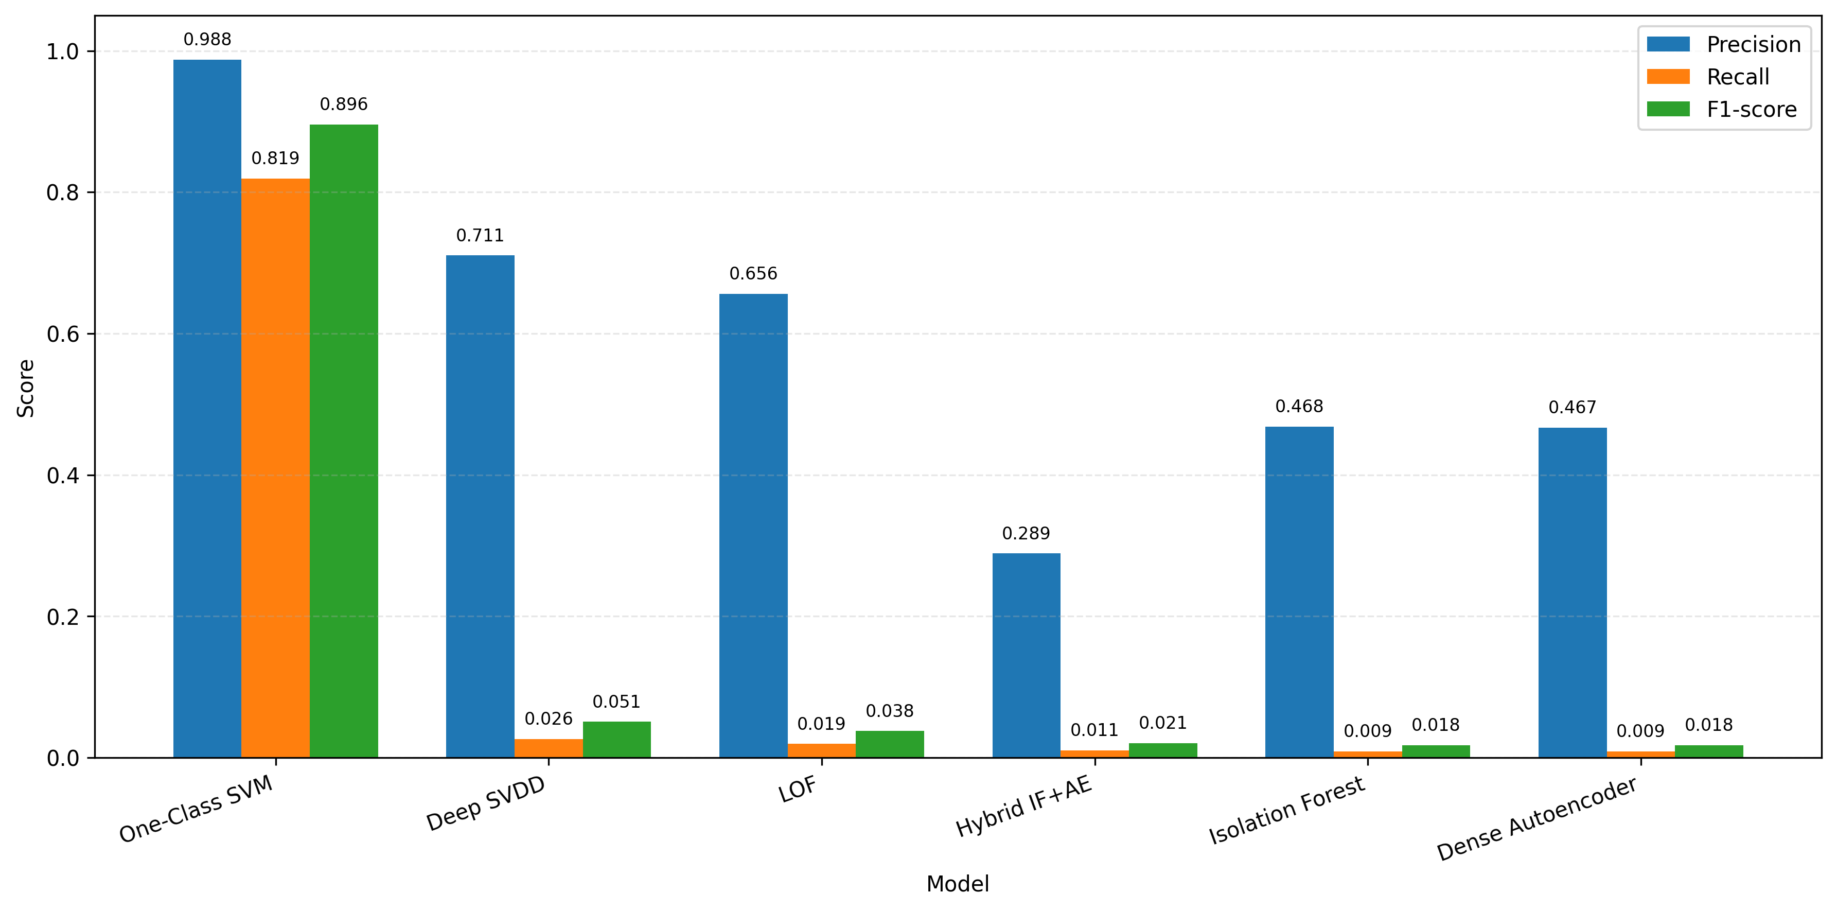
Figure 1G. NF-CSE-CIC-IDS2018 precision, recall and F1-score after 1% normal-only target-domain threshold recalibration (project-generated result).

14.5 False-Positive Results
Model | FPR (%) | Alerts per 1,000 | Budget met?
LOF | 1.02 | 10.2 | Yes
Isolation Forest | 1.03 | 10.3 | Yes
One-Class SVM | 1.03 | 10.3 | Yes
Dense Autoencoder | 1.04 | 10.4 | Yes
Deep SVDD | 1.08 | 10.8 | Yes
Hybrid IF+AE | 2.63 | 26.3 | No

Recalibration worked. Five of six models landed within 0.1 points of the 1% budget, down from 93–100% in Stage 1. Only the Hybrid missed, for reasons covered in Section 19.

14.6 Confusion-Matrix Results
One-Class SVM:
 | Predicted normal | Predicted attack
Actually normal | 296,923 | 3,077
Actually attack | 54,229 | 245,771

Isolation Forest:
 | Predicted normal | Predicted attack
Actually normal | 296,911 | 3,089
Actually attack | 297,279 | 2,721

The false-positive column is almost identical in both — 3,077 against 3,089. The entire difference is in the attack row: 245,771 caught against 2,721. Same budget, same alert load, and only one of them is a working detector.

14.7 Before-vs-After Recalibration Comparison
Model | FPR before | FPR after | Recall before | Recall after
One-Class SVM | 100% | 1.03% | 1.000 | 0.819
Deep SVDD | 100% | 1.08% | 1.000 | 0.027
Dense Autoencoder | 100% | 1.04% | 1.000 | 0.009
Hybrid IF+AE | 100% | 2.63% | 1.000 | 0.011
Isolation Forest | 93.67% | 1.03% | 0.997 | 0.009
LOF | 93.30% | 1.02% | 0.996 | 0.020

The Stage 1 recall of ~1.000 was never detected — it was the threshold flagging everything. Recalibration removes that artefact and shows what each model can actually find at an operational false-positive rate. For five of them, the answer is almost nothing.

14.8 Model-Specific Recalibration Behaviour
One-Class SVM — fully successful. Recall 0.819, precision 0.988, FPR 1.03%. Its Stage 1 ROC-AUC of 0.889 said the ranking was sound; fixing the threshold turned that ranking into working detection.
Isolation Forest and LOF — budget met, detection lost. Both have NF-CSE ROC-AUC below 0.57, so the ranking itself is weak. A correct threshold cannot rescue a model that is not separating the classes.
Dense Autoencoder — the inverted-score case. ROC-AUC 0.126, unchanged by recalibration because AUC does not depend on the threshold.
Hybrid IF+AE — threshold saturation. Missed its budget at 2.63%. Its scores are bunched at the top of the range and the percentile rule cannot separate them. Section 19 analyses this.
Deep SVDD — partial. FPR 1.08% with recall 0.027 at this budget, but Section 16 shows it reaches recall 0.637 at a wider one.

15. Stage 3 — Parameter Sensitivity Testing

15.1 Purpose of Stage 3
Stage 2 reported one operating point per model. Stage 3 asks whether that point was stable or lucky. If the budget moves a little, do the results move a little, or do they swing? A model whose recall doubles when the budget shifts by one point cannot be deployed with confidence, because the calibration sample will never be perfectly representative.

15.2 Threshold-Sensitivity Methodology
The same percentile rule, run six times per model. Models stay frozen, the calibration data stays the same, the held-out test set stays the same. Only the percentile changes.
Because ROC-AUC and PR-AUC are threshold-independent, they are identical across all six budgets. Anything that does change — recall, precision, F1, FPR — changed because of the threshold alone.

15.3 0.5% Calibration Budget
The strictest setting tested: 5 false alerts per 1,000 records. The tightest budget a cautious SME deployment would choose.

15.4 1% Calibration Budget
The project’s operating point, carried forward from Stages 1 and 2, and the reference the other five budgets are compared against.

15.5 2% Calibration Budget
One step looser, to test whether a small relaxation produces a small or a large change in detection.

15.6 3% Calibration Budget
30 false alerts per 1,000 records — already near the edge of what a small team can process.

15.7 5% Calibration Budget
50 alerts per 1,000. Beyond practical use for an SME; included to map the curve rather than to recommend it.

15.8 10% Calibration Budget
100 alerts per 1,000. Clearly unusable, but it marks the upper end and shows how much detection exists if false positives are ignored.
Budgets of 5% and 10% are diagnostic. They answer “how much detection exists in this model at any threshold?”, which is a different question from “what should we deploy?”

15.9 Consistent Test Set
NF-CSE was swept across all six budgets on the same 600,000 held-out records used in Stage 2, which makes the six budgets directly comparable with each other and with the Stage 2 result.
UNSW was swept across three budgets — 0.5%, 1% and 3% — on the full 82,332-record test partition. The in-domain sweep is narrower because it was produced alongside the Stage 1 run rather than as a separate experiment. Section 23 records this as a limitation.

15.10 Stage 3 Verification
Check | Expected | Result
Budgets tested per model (NF-CSE) | 6 | 6
ROC-AUC and PR-AUC constant across budgets | Constant | Constant
Threshold falls as budget rises | Monotonic | Failed for Hybrid IF+AE
Calibration records in the test set | 0 | 0
Confusion matrix totals | 600,000 | Match

The constant-AUC check passed, confirming the models were untouched across all 36 runs. The monotonic check failed for one model: Hybrid IF+AE returned only two distinct thresholds across six budgets. A threshold that does not move when the percentile changes means the underlying scores are tied, which Section 19 examines.

16. Stage 3 Parameter Sensitivity Results

16.1 Threshold Values Across Budgets
NF-CSE thresholds at each budget:
Model | 0.5% | 1% | 2% | 3% | 5% | 10%
Isolation Forest | 0.69361 | 0.69188 | 0.69009 | 0.68929 | 0.68818 | 0.68664
Dense Autoencoder | 0.48980 | 0.45027 | 0.42324 | 0.40753 | 0.38860 | 0.36866
Hybrid IF+AE | 0.999903 | 0.999903 | 0.999903 | 0.999854 | 0.999854 | 0.999854
LOF | 9.09135 | 8.33628 | 7.64019 | 7.54442 | 7.35778 | 7.09926
One-Class SVM | 19.4364 | 19.4341 | 19.4319 | 19.4300 | 16.6407 | 16.2718
Deep SVDD | 0.026315 | 0.023528 | 0.021358 | 0.019734 | 0.016950 | 0.013745

Thresholds fall as the budget widens, as expected — except Hybrid IF+AE, which takes only two distinct values across six budgets.

16.2 Recall vs False-Positive Rate
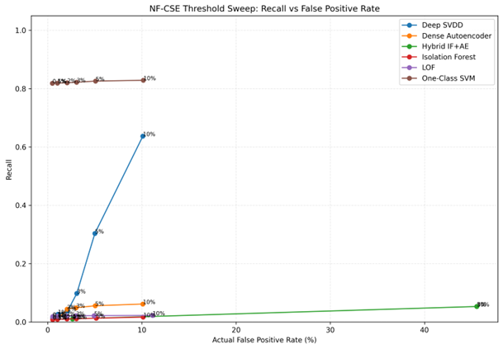
Figure 2. NF-CSE threshold sweep — recall against actual false-positive rate.
NF-CSE recall at each budget:
Model | 0.5% | 1% | 2% | 3% | 5% | 10%
One-Class SVM | 0.818 | 0.819 | 0.820 | 0.822 | 0.826 | 0.829
Deep SVDD | 0.014 | 0.027 | 0.038 | 0.098 | 0.304 | 0.637
Dense Autoencoder | 0.008 | 0.009 | 0.044 | 0.049 | 0.056 | 0.062
LOF | 0.019 | 0.019 | 0.021 | 0.021 | 0.022 | 0.023
Isolation Forest | 0.008 | 0.009 | 0.010 | 0.011 | 0.013 | 0.017
Hybrid IF+AE | 0.011 | 0.011 | 0.011 | 0.053 | 0.053 | 0.053

UNSW recall across its three budgets, for comparison:
Model | 0.5% | 1% | 3%
LOF | 0.344 | 0.523 | 0.753
Deep SVDD | 0.533 | 0.595 | 0.693
Hybrid IF+AE | 0.613 | 0.626 | 0.679
Dense Autoencoder | 0.589 | 0.633 | 0.674
Isolation Forest | 0.609 | 0.617 | 0.664
One-Class SVM | 0.296 | 0.340 | 0.423

In-domain, every model gains recall as the budget widens, and the gains are moderate and even. LOF is the exception — it more than doubles, from 0.344 to 0.753, which makes it the most budget-sensitive model on its own training domain.

16.3 F1-Score vs False-Positive Rate
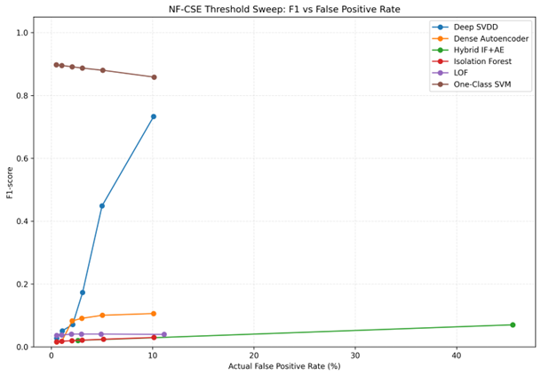
Figure 3. NF-CSE threshold sweep — F1 against actual false-positive rate.
Model | NF-CSE best F1 | At budget | UNSW best F1 (of three budgets)
One-Class SVM | 0.898 | 0.5% | 0.569 at 3%
Deep SVDD | 0.733 | 10% | 0.786 at 3%
Isolation Forest | 0.030 | 10% | 0.766 at 3%
Hybrid IF+AE | 0.070 | 3% | 0.778 at 3%
Dense Autoencoder | 0.106 | 10% | 0.775 at 3%
LOF | 0.041 | 2% | 0.822 at 3%

One-Class SVM is the only model whose best cross-domain F1 occurs at the strictest budget. For every other model F1 improves as the budget widens, which means detection is being bought with false alarms.

16.4 Precision Across Budgets
Precision falls as budgets widen, and the decline is steepest where the model ranks poorly. On NF-CSE, Isolation Forest goes from 0.611 to 0.142 and LOF from 0.781 to 0.169 across the full range, while One-Class SVM loses only ten points, from 0.994 to 0.891. In-domain the picture is gentler: all six stay between 0.87 and 0.95 across the three budgets.

16.5 Model-Specific Sensitivity
Model | Behaviour | Evidence
One-Class SVM | Stable | NF-CSE recall 0.818 → 0.829 across all six budgets
Deep SVDD | Highly sensitive | NF-CSE recall 0.014 → 0.637, a 45× change
Isolation Forest | Stable but weak | NF-CSE 0.008 → 0.017 — more budget buys nothing
LOF | Weak cross-domain, sensitive in-domain | NF-CSE 0.019 → 0.023; UNSW 0.344 → 0.753
Dense Autoencoder | Erratic | NF-CSE jumps 0.009 → 0.044 between 1% and 2%
Hybrid IF+AE | Two-state | Only two distinct thresholds across six budgets

16.6 Stable Threshold Behaviour
One-Class SVM on NF-CSE is the only genuinely stable model. Its recall varies by 1.1 percentage points across a budget range of 0.5% to 10%, and its threshold barely moves over the first four budgets (19.4364 to 19.4300).
Stability here means the score distribution has a clear gap between normal and attack traffic. Moving the cut-point within that gap changes almost nothing. This matches its ROC-AUC of 0.889 — the highest of any model on that domain.
Isolation Forest on NF-CSE is also stable, but stably useless: recall stays between 0.008 and 0.017 whatever the budget.

16.7 Unstable Threshold Behaviour
Deep SVDD is the clearest instability case. On NF-CSE its recall goes 0.014, 0.027, 0.038, 0.098, 0.304, 0.637. Between the 3% and 5% budgets alone it triples.
That means its score distribution has no clean separation. Attack and normal scores are interleaved, so every small threshold movement crosses a dense region of records. A calibration sample slightly unrepresentative of live traffic would place the threshold somewhere quite different, and the deployed behaviour would not match the tested behaviour.
Hybrid IF+AE is unstable in the opposite way. Its false-positive rate takes two values and jumps between them — 2.63% at the first three budgets, then 45.55% at the last three. There is no intermediate behaviour available at all. Section 19 explains why.

16.8 Diminishing-Return Behaviour
Deep SVDD on NF-CSE shows the trade-off most clearly:
Budget | FPR (%) | Recall | Recall gained per extra FPR point
0.5% | 0.53 | 0.014 | —
1% | 1.04 | 0.027 | 0.03
2% | 2.06 | 0.038 | 0.01
3% | 3.09 | 0.098 | 0.06
5% | 5.13 | 0.304 | 0.10
10% | 10.10 | 0.637 | 0.07

Deep SVDD is unusual in that its returns do not diminish within the tested range — but reaching recall 0.637 costs a 10% false-positive rate, which is 100 alerts per 1,000 records and well past what an SME can process. The useful range for this model ends somewhere around the 3% budget.
For Isolation Forest and LOF the returns are flat from the start. Twentyfold more budget buys LOF 0.4 points of recall and 31,813 extra false alerts.

16.9 Stage 3 Findings
F10. One-Class SVM is stable — recall varies by 1.1 points across a twentyfold budget range. It is the only model that could be deployed without precise calibration.
F11. Deep SVDD is the most budget-sensitive model, with a 45× recall change. Its tested performance would not predict its deployed performance.
F12. Hybrid IF+AE has only two reachable operating states across six budgets.
F13. Stability tracks ROC-AUC. Models above 0.83 respond predictably; models below 0.57 do not benefit from any budget.
F14. In-domain, widening the budget helps every model moderately — and helps LOF a great deal, from recall 0.344 to 0.753. Cross-domain it helps only Deep SVDD.
F15. No model reached its budget exactly at any setting.

17. Comparative Analysis of the Three Testing Stages
Each stage changed one thing, so the differences between them isolate the effect of that change.

17.1 Stage 1 vs Stage 2
Model (NF-CSE) | FPR S1 | FPR S2 | Recall S1 | Recall S2
One-Class SVM | 100% | 1.03% | 1.000 | 0.819
Deep SVDD | 100% | 1.08% | 1.000 | 0.027
Dense Autoencoder | 100% | 1.04% | 1.000 | 0.009
Hybrid IF+AE | 100% | 2.63% | 1.000 | 0.011
Isolation Forest | 93.67% | 1.03% | 0.997 | 0.009
LOF | 93.30% | 1.02% | 0.996 | 0.020

Recalibration solved the false-positive problem and exposed a second one. False positives fell from 93–100% to about 1%. But the Stage 1 recall of ~1.000 was never detection — it was a threshold sitting below every score in the domain. Once the threshold was placed correctly, five of six models turned out to detect under 3% of attacks.
Nothing about the models changed between those two columns. Only the number they were compared against.

17.2 Stage 2 vs Stage 3
Model (NF-CSE) | Stage 2 recall | Stage 3 range | Verdict
One-Class SVM | 0.819 | 0.818 – 0.829 | Stable
Deep SVDD | 0.027 | 0.014 – 0.637 | Highly sensitive
Hybrid IF+AE | 0.011 | 0.011 – 0.053 | Two states only
Dense Autoencoder | 0.009 | 0.008 – 0.062 | Erratic
LOF | 0.020 | 0.019 – 0.023 | Flat and low
Isolation Forest | 0.009 | 0.008 – 0.017 | Flat and low

Stage 2 alone would have been misleading for Deep SVDD. Its single figure of 0.027 hides a 45-fold range, and the model reaches recall 0.637 at a wider budget. For the others, Stage 3 confirms that the Stage 2 figure was representative.

17.3 Original vs Recalibrated Thresholds
Model | UNSW (original) | NF-CSE (recalibrated) | Shift
Isolation Forest | 0.546054 | 0.691877 | 1.3×
Dense Autoencoder | 0.036468 | 0.450272 | 12×
Hybrid IF+AE | 0.980082 | 0.999903 | 1.02×
LOF | 1.800995 | 8.336277 | 4.6×
One-Class SVM | −0.000053 | 19.434098 | sign change
Deep SVDD | 0.000055 | 0.023528 | 428×

The scale of these changes rules out the idea that a benchmark threshold is approximately right elsewhere.

17.4 Detection Improvement
Model | Usable detection before | Usable detection after | Change
One-Class SVM | None — flagged everything | Recall 0.819, F1 0.896 | Recovered
Deep SVDD | None — 100% FPR | Recall 0.027 at 1%, 0.637 at 10% | Partial
The other four | None | Recall below 0.021 at 1% | No recovery

The predictor was ROC-AUC. One-Class SVM entered Stage 2 with a cross-domain ROC-AUC of 0.889 and came out with recall 0.819. Every model that entered below 0.57 came out below recall 0.021. Ranking ability determined whether a correct threshold was worth anything.

17.5 False-Positive Trade-Off
Model (NF-CSE) | Recall at 0.5% | Recall at 10% | Cost of the gain
One-Class SVM | 0.818 | 0.829 | Negligible gain — already at its ceiling
Deep SVDD | 0.014 | 0.637 | 28,706 extra false alerts
Isolation Forest | 0.008 | 0.017 | 28,828 extra alerts for 0.9 points
LOF | 0.019 | 0.023 | 31,813 extra alerts for 0.4 points

For Isolation Forest and LOF the trade is not worth making at any budget.

17.6 Cross-Domain Behaviour
The in-domain ranking is almost exactly reversed cross-domain. The worst model on UNSW is the best on NF-CSE, and the best on UNSW is among the worst. A benchmark leaderboard would have picked the wrong model.

17.7 Model-Specific Differences
One-Class SVM. Worst in-domain (F1 0.492), best cross-domain after recalibration (F1 0.896), and the only model stable across all six budgets.
Dense Autoencoder. Best in-domain F1 (0.755) and a ROC-AUC of 0.126 on NF-CSE, meaning inverted ranking. The strongest benchmark result in the set belongs to the model with the clearest cross-domain fault.
Deep SVDD. The only model besides One-Class SVM with real cross-domain detection available, but the most budget-sensitive of the six.
Isolation Forest and LOF. Solid in-domain, effectively random on NF-CSE (ROC-AUC 0.464 and 0.569). Neither benefits from any budget.
Hybrid IF+AE. Good in-domain (F1 0.753) but only two reachable operating states cross-domain, and it missed its budget at 2.63%.

17.8 Operational Interpretation
- A benchmark result is not a deployment forecast. The in-domain ranking was reversed cross-domain.
- The threshold must be set on the network it will run on. It cannot be shipped with the model.
- Recalibration is necessary but not sufficient. It restored the budget for five of six models and restored detection for one.
- Check ROC-AUC on target-domain traffic before deploying. It predicted which models recalibration would rescue, and it needs only a small labelled sample — collected once for validation, not for operation.
- Sweep the budget before committing to one. A single operating point hid a 45-fold range in Deep SVDD. Taken together, the three stages show that the decision rule, not the model, was the weakest part of this system — and that fixing it reveals how much of the original performance was never real.

18. False-Positive Analysis

18.1 Validation FPR vs Held-Out FPR
Measurement | Budget | Measured | Gap
On the calibration records themselves | 1% | ~1.00% | None, by definition
UNSW validation → UNSW test partition | 1% | 2.13% | 2.1×
UNSW validation → UNSW test, six models | 1% | 4.35 – 5.70% | 4 – 6×
UNSW validation → NF-CSE | 1% | 93.3 – 100% | 93 – 100×

The gap opens before any domain change. Two partitions of the same dataset already produced a doubling. The cross-domain figures are the same failure at a larger scale, not a different one.

18.2 Calibration Budget vs Actual Test FPR
Budget | NF-CSE measured range | On target? | Models within 0.1 pts
0.5% | 0.50 – 2.63% | Mostly | 4 of 6
1% | 1.02 – 2.63% | Mostly | 5 of 6
2% | 1.98 – 2.63% | Mostly | 5 of 6
3% | 2.97 – 45.55% | Partly | 4 of 6
5% | 4.91 – 45.55% | Partly | 4 of 6
10% | 10.10 – 45.55% | Partly | 5 of 6

With 100,000 calibration records, NF-CSE lands close to its budget for most models. The outlier in every row is the Hybrid.

18.3 False Alert Counts
Percentages understate the workload. The same results as daily volumes, for a network carrying 100,000 flows a day:
Scenario | FPR | Alerts / 1,000 | False alerts per day
Budget as intended | 1% | 10 | 1,000
UNSW in-domain, measured | 4.35 – 5.70% | 43 – 57 | 4,350 – 5,700
NF-CSE, frozen threshold | 93.3 – 100% | 933 – 1,000 | 93,300 – 100,000
NF-CSE, recalibrated | 1.02 – 2.63% | 10 – 26 | 1,020 – 2,630

Even the best case asks a one- or two-person team to review roughly 1,000 alerts a day, almost all of them false. That is the figure that should drive model selection.

18.4 Distribution Shift and False Alerts
False alerts rise because the normal score distribution moves while the threshold stays still. Two measurements show this.
- Within UNSW-NB15. Six of 41 columns shifted significantly between training and testing, all of them traffic-volume features, and the 1% threshold gave 2.13%.
- Between UNSW and NF-CSE. All 400,000 NF-CSE normal records scored above the threshold for four of six models. The threshold is no longer in the tail of the distribution — the whole distribution is past it.
The first point is the more worrying one. If the distribution moves between two partitions of one synthetic dataset, it will certainly move on a production network over weeks and months.

18.5 Effect of Threshold Relaxation
Model (NF-CSE) | Recall 0.5% | Recall 10% | FP at 0.5% | FP at 10%
Deep SVDD | 0.014 | 0.637 | 1,590 | 30,296
One-Class SVM | 0.818 | 0.829 | 1,493 | 30,435
Isolation Forest | 0.008 | 0.017 | 1,561 | 30,389
LOF | 0.019 | 0.023 | 1,571 | 33,384

Relaxation helps only Deep SVDD. For One-Class SVM it adds 28,942 false alerts for 1.1 points of recall — the model is already at its ceiling. For Isolation Forest and LOF it buys almost nothing at any price.
Relaxing the threshold cannot compensate for a model that does not rank well.

18.6 Implications for SME Financial Services
- Calibrate on the client’s own normal traffic, collected during ordinary operation, and never on benchmark data.
- Collect enough of it. The 100,000-record NF-CSE calibration met its budget for five of six models. This experiment does not establish a minimum normal-flow sample size.
- Recalibrate on a schedule, not once at install. The distribution moved measurably even within one dataset.
- State the alert volume, not the percentage, in any commitment to the client. “1% false positives” and “about 1,000 alerts a day” describe the same system, and only the second is checkable against their capacity to respond.
The honest position is that a false-positive budget is a design target, not a guarantee, and the gap between the two is a property of the traffic rather than of the software.

19. Anomaly Score and Threshold Behaviour Analysis
Every result here comes from comparing a score with a threshold. This section looks at the scores themselves, using the UNSW record-level outputs, and explains why the Hybrid model could not be calibrated.

19.1 Normal Score Distribution
Model | Median | 99th pct | Maximum
Isolation Forest | 0.3969 | 0.6317 | 0.6898
Dense Autoencoder | 0.0029 | 0.1255 | 0.3979
Hybrid IF+AE | 0.5609 | 0.9993 | 0.9997
LOF | 1.0929 | 2.8653 | 7700.97
Deep SVDD | 0.000005 | 0.000259 | 0.012292

LOF’s maximum of 7,700 against a 99th percentile of 2.87 shows how long its tail is — a handful of normal records score a thousand times higher than the rest.

19.2 Attack Score Distribution
Model | Attack 10th pct | Attack median
Isolation Forest | 0.3888 | 0.6104
Dense Autoencoder | 0.0043 | 0.0648
Hybrid IF+AE | 0.6178 | 0.9981
LOF | 1.2187 | 1.8185
Deep SVDD | 0.000007 | 0.000112

19.3 Score Overlap
Comparing the two tables shows how much the classes overlap. For every model, the attack 10th percentile sits below the normal 99th percentile — so a threshold placed at the 99th percentile of normals will always miss a large share of attacks. That is the structural reason in-domain recall tops out around 0.63.
Overlap is what ROC-AUC measures. The models with the least overlap are the ones that responded predictably to recalibration.

19.4 Threshold Position
On UNSW the threshold lands where a percentile rule should put it — between the median and the 99th percentile of normal scores, for all six models. That is why the in-domain false-positive rate is wrong by a factor of five rather than a factor of a hundred.
On NF-CSE it does not land there. For the four models at 100% false positives, the threshold sits below the entire normal distribution. The threshold did not move; the distribution moved past it.

19.5 Score Saturation
Saturation is when a model’s scores crowd against the top of their range, leaving no room to distinguish records.
Model | Distinct score values | Of 82,332 records
Deep SVDD | 53,606 | 65%
One-Class SVM | 53,603 | 65%
Dense Autoencoder | 53,556 | 65%
LOF | 52,578 | 64%
Isolation Forest | 52,012 | 63%
Hybrid IF+AE | 20,316 | 25%

The Hybrid produces roughly 40% as many distinct values as the others on the same records. Its score has collapsed onto far fewer levels.

19.6 Score Ties
Saturation produces ties — many records sharing one exact value. On UNSW, the largest tie in every other model holds 678 records, or 0.8%. The Hybrid’s largest tie holds 3,823 records, or 4.6% — nearly six times as many.
A percentile cannot cut inside a tie. If one value spans several percentile points, asking for the 99th, 98th or 97th percentile returns the same number, and the resulting false-positive rate is whatever that tie boundary happens to give rather than what the budget asked for.

19.7 Hybrid Threshold Behaviour
This explains every anomaly in the Hybrid results.
Observation | Where | Cause
Only two distinct thresholds across six budgets | NF-CSE, Stage 3 | Tied values span whole percentile ranges
FPR jumps 2.63% → 45.55% with nothing between | NF-CSE, Stage 3 | Only two tie levels are reachable
Missed the 1% budget at 2.63% | NF-CSE, Stage 2 | The cut falls at a tie boundary, not where the budget asked
Four times the tie size of any other model | UNSW, record level | Score compressed against the top of its range

The Hybrid cannot be calibrated by the percentile method. This is not a tuning problem to be solved with more budgets — the score has too few distinct values for any percentile rule to place a meaningful cut.
The likely cause is how the two component scores are combined. If the rule takes a maximum, or multiplies values already close to 1, the output compresses against the ceiling and the information in the individual scores is lost. Section 24 recommends rebuilding it.

19.8 Implications for Threshold Calibration
- Check the score distribution before calibrating. Counting distinct values takes one line of code and would have caught the Hybrid problem before any results were produced.
- Verify that the threshold changes when the budget changes. An unchanged threshold across budgets is a defect signal, and it is now part of the Stage 3 checklist.
- Treat overlap as a deployment criterion. Models whose attack scores interleave with normal ones will be threshold-sensitive wherever they run.
A percentile rule assumes a continuous, well-spread score distribution. Where that assumption fails, the rule fails silently — it returns a number, and nothing in the output says the number is meaningless.

20. Testing Verification and Quality Assurance

20.1 Feature Count Verification
21 portable features expand to 41 model-ready columns. I checked the count at every stage boundary — after preprocessing, and at the input to Stages 1, 2 and 3 in both domains. 41 every time.

20.2 Feature Order Verification
The saved order in feature_order.json was compared against the column order of every array before scoring. An order mismatch raises no error — the model simply reads the wrong column — so this is checked explicitly rather than assumed. Exact match at every checkpoint.

20.3 Preprocessor Verification
Fitted on normal training data only, saved, and reloaded at every stage. Never refitted, and the same object used for both domains.

20.4 Model Loading Verification
All six models loaded from saved files at the start of each stage. None retrained, refitted or tuned. The evidence is in 24.8: ROC-AUC is identical for a given model and domain across every stage and budget, which a changed model could not produce.

20.6 Prediction Verification
Record-level scores and predictions were exported for every model and domain, so any figure in Sections 11, 14 and 16 can be recomputed without re-running a model. The prediction rule was applied identically in both domains, with no per-domain adjustment.

20.8 Metric Calculation Verification
Worked example, NF-CSE Stage 2, One-Class SVM. TP 245,771 + FN 54,229 = 300,000 attack records. FP 3,077 + TN 296,923 = 300,000 normal records. Recall 245,771 / 300,000 = 0.819. FPR 3,077 / 300,000 = 1.03%. All match the reported figures.
ROC-AUC and PR-AUC were confirmed constant across budgets, as they must be.

20.9 Calibration/Test Separation Verification
Domain | Calibration | Held-out test | Overlap
NF-CSE | 100,000 normal | 600,000 | 0
UNSW (Stage 1) | 10,266 normal | 82,332 | 0

A threshold measured on its own calibration records reproduces its budget almost exactly and says nothing about new traffic. This check is what makes the Stage 2 and Stage 3 figures meaningful.

20.10 Reproducibility Verification
Seed 42 in every script. Fixed split, saved preprocessor, stored feature order, thresholds written to JSON with their budgets, package versions pinned, and all results exported to CSV, Excel and JSON.
One limitation belongs here: no multi-seed run was performed, so the results are reproducible but their variance under a different split is unmeasured.

21. Critical Evaluation

21.1 Key Technical Findings
1. A false-positive budget is a design target, not a guarantee. No threshold delivered its budget on held-out data in any stage or domain.
2. Threshold transfer and model transfer are separate failures. One-Class SVM’s ROC-AUC rose to 0.889 on NF-CSE while its threshold produced 100% false positives.
3. Recalibration restores the budget but not detection. Five of six models fell below recall 0.027 once their false-positive rate was corrected.
4. ROC-AUC on target-domain traffic predicts whether recalibration will help. Above 0.83 it did; below 0.57 it did not.
5. A score distribution can be too compressed to calibrate, as the Hybrid model’s 20,316 distinct values against the others’ 53,000 shows.

21.2 Practical Significance of the Results
- Recalibration must be a scheduled operation, not an install step. The dashboard workstream needs a recalibration path, not a fixed threshold in a configuration file.
- Two models should not ship in their current form. Hybrid IF+AE cannot be calibrated, and the Dense Autoencoder’s inverted ranking is unexplained.
- Model selection should use target-domain ROC-AUC, not benchmark F1. This report shows benchmark F1 pointing the wrong way.
For the client, the honest statement is that this system can be tuned to a chosen false-alarm load, that the load must be re-tuned as their traffic changes, and that the detection available at an acceptable load is well below what benchmark figures suggest.

22. Limitations

22.1 UNSW-NB15 Limitations
- Synthetic traffic generated by IXIA PerfectStorm, which leaves artefacts — the reason the TTL features are so predictive and were excluded.
- Unrealistic class balance. Attacks are 55% of the testing partition; on a real network they are a fraction of a percent, so every precision figure is optimistic.
- Internal inconsistency. Six of 41 columns shifted between the two partitions.
- Age. The dataset is from 2015.

22.2 Cross-Domain Evaluation Limitations
- One external domain. NF-CSE-CIC-IDS2018 alone. One domain shows transfer can fail; it cannot measure how often.
- No record-level export for NF-CSE. The score analysis in Section 19 therefore rests on UNSW data, with NF-CSE inferred from confusion-matrix counts.
- The Dense Autoencoder’s inverted ranking is unexplained. ROC-AUC 0.126 may indicate a sign convention error in how reconstruction error becomes an anomaly score, but I did not confirm this. Until it is confirmed, that model’s cross-domain results should not be cited as evidence about autoencoders in general.

22.3 Calibration Data Limitations
- Stage 2 was not run in-domain. UNSW is the calibration domain, so there is nothing to recalibrate to. The in-domain evidence therefore comes from the parameter sweep rather than from a recalibration run.
- Calibration traffic came from one capture per domain. A production network draws from many sources with different distributions.
- No measurement of calibration-set size. I used 100,000 NF-CSE normals because they were available, not because that size was shown to be sufficient.

22.4 Threshold-Based Decision Limitations
- A single global threshold is a crude rule. One number per model applies the same standard to every host, service and time of day.
- The percentile method assumes a well-spread score distribution. Where that fails, as with the Hybrid, the method returns a number and nothing signals that the number is meaningless.
- Thresholds were tested at a point in time. I did not measure how quickly a calibrated threshold degrades as traffic drifts.

22.5 Small Scenario Sample Limitations
- The in-domain sweep used three budgets, not six. It was produced alongside the Stage 1 run rather than as a separate experiment, so the UNSW sensitivity curve is coarser than the NF-CSE one.
- Attack categories are very uneven. Worms has 130 records in the training partition against Generic’s 40,000, so any per-category statement rests on very different sample sizes.
- Two datasets, both synthetic. Neither UNSW-NB15 nor NF-CSE-CIC-IDS2018 is a recording of a production network.

22.6 Generalisation Limitations
- Six models, two domains, one seed. The findings are consistent across this set, but the set is small.
- No multi-seed validation. The variance of these results under a different split is unmeasured.
- Offline testing only. Records were scored as files, so nothing here measures latency, throughput or behaviour under load.
- The findings are about this pipeline. They are consistent with the published cross-dataset literature, but a six-model study does not establish a general law.

23. Recommendations and Future Testing

23.1 Representative Normal Calibration
Calibrate on normal traffic from the network where the system will run, collected over a period long enough to include routine variation — business hours and overnight, weekday and weekend, backup windows and month-end processing.
The 100,000-record NF-CSE calibration produced near-budget held-out FPR for five of six models, but this experiment did not determine the minimum sample size required. Calibration records should represent relevant days, hours, protocols, services and network behaviours; performance must be validated on separate traffic.

23.2 Multi-Source Calibration
Calibration should draw from every traffic source the system will see, in roughly the proportions it will see them. Where sources differ substantially, per-source thresholds are worth testing against a single global one.

23.3 Adaptive Thresholding
A fixed threshold assumes a fixed distribution, and that assumption failed even within one dataset. Three approaches are worth testing:
- Scheduled recalibration — recompute weekly or monthly from recent normal traffic. Simple, and it addresses the observed drift directly.
- Rolling-window thresholds — calculate the percentile over a moving window so the threshold tracks drift continuously.
- Drift detection as a trigger — monitor the normal score distribution and recalibrate when it moves beyond a tolerance.
All three need the same measurement first: how quickly a calibrated threshold degrades. That does not exist yet and should be the next experiment.

23.4 Additional Practical Traffic
Both datasets used here are synthetic. Future testing should add attack types closer to what a financial services SME would face — credential stuffing, exfiltration over permitted protocols, lateral movement and slow reconnaissance — and traffic captured from a real network rather than generated.

23.5 Multi-Seed Validation
Every result here comes from seed 42. The full three-stage pipeline should be repeated with at least five seeds, reporting the mean and spread of each metric. This matters most for Deep SVDD, whose recall ranged 45-fold across budgets at one seed; the variance across seeds is unknown and may be comparable.

23.6 Long-Term Production Testing
The gap this work cannot close is time. Everything here is a snapshot — models trained once, thresholds calibrated once, traffic captured once.
A realistic deployment test would run the pipeline against a live feed for several weeks, recalibrating on a schedule, and record how the false-positive rate moves between recalibrations. That would turn the recommendation in 28.3 from a reasonable idea into a specified operating procedure.
Two engineering items should be fixed first: the Hybrid combination rule needs rebuilding so its scores are not compressed against 1.0, and the Dense Autoencoder’s score direction needs checking against its ROC-AUC of 0.126.

23.7 Threshold Governance and Rollback
Treat a threshold change as a controlled security-configuration change. Store the previous approved value, the new calibration sample, requested budget, exact threshold, reviewer and validation outcome. If held-out FPR or analyst workload becomes unstable after deployment, the decision layer should be able to roll back without changing the model.

24. Conclusion
I ran a three-stage test of six unsupervised models across two domains, using the prepared dataset from Technical Artefact 1. The models, the preprocessor and the feature order stayed frozen throughout. Only the decision threshold changed.
Stage 1 applied the UNSW threshold unchanged. In-domain it produced 4.35% to 5.70% false positives against a 1% budget. On NF-CSE-CIC-IDS2018 it produced 93.3% to 100%, with four of six models flagging every one of 700,000 records.
Stage 2 recalculated the threshold from NF-CSE normal traffic, using no attack labels. Five of six models returned to within 0.1 points of the 1% budget. Only One-Class SVM kept useful detection, at recall 0.819. The other five fell below recall 0.027, which revealed that their Stage 1 recall of ~1.000 had never been detection at all.
Stage 3 swept six budgets from 0.5% to 10%. One-Class SVM varied by 1.1 points of recall across that range; Deep SVDD varied 45-fold; Hybrid IF+AE had only two reachable operating states because its scores are compressed into too few distinct values.
Three conclusions follow.
1. A false-positive budget is a design target, not a guarantee. No threshold delivered its budget on data it had not been calibrated on — not across domains, and not even across two partitions of the same dataset.
2. Threshold failure and model failure are different problems and need different fixes. One-Class SVM ranked attacks correctly on NF-CSE while flagging every record, and recalibration fixed it. Isolation Forest ranked at 0.464 on the same data, and no threshold could help it.
3. A benchmark score is not a deployment forecast. The in-domain ranking was almost exactly reversed cross-domain. A benchmark leaderboard would have selected the wrong model.
For the SME deployment this project is building towards, the practical requirements are that the threshold be calibrated on the client’s own normal traffic, that it be recalibrated as that traffic changes, and that any commitment to the client be stated as a daily alert volume rather than a percentage. The detection available at an acceptable alert load is well below what the benchmark figures suggest, and saying so is more useful to the client than a headline accuracy figure would be.
The threshold framework strengthens the testing result by making the decision layer auditable. The same frozen scores can support very different operating behaviour depending on τ, so deployment decisions must preserve calibration/test separation, threshold provenance, sensitivity evidence and an approved recalibration path. This is the main reason the report treats threshold quality as a separate engineering concern from model quality.

25. References
Axelsson, S. (2000). The base-rate fallacy and the difficulty of intrusion detection. ACM Transactions on Information and System Security, 3(3), 186-205.
Cantone, M., Marrocco, C., & Bria, A. (2024). On the cross-dataset generalization of machine learning for network intrusion detection. IEEE Access, 12, 144489-144508.
Fan, W., Yao, J., Cui, S., Wang, Y., Xu, S., Tan, Y., Yang, F., & Wu, W. (2024). Bi-LSTM/GRU-based anomaly diagnosis for virtual network function instance. Computer Networks, 249, Article 110515.
Kaya, M. O., Ozdem, M., & Das, R. (2025). A new hybrid approach combining GCN and LSTM for real-time anomaly detection from dynamic computer network data. Computer Networks, 268, Article 111372.
Maspo, N.-A., Ghulam Hussain, M. T., Shafeeq Lone, A., & Mahmod Attar Bashi, Z. S. (2026). Anomaly detection of denial-of-service network traffic attacks using autoencoders and isolation forest. International Journal on Perceptive and Cognitive Computing, 12(1), 145-151.
Moustafa, N., & Slay, J. (2015). UNSW-NB15: A comprehensive data set for network intrusion detection systems. In 2015 Military Communications and Information Systems Conference (MilCIS) (pp. 1-6). IEEE.
Sommer, R., & Paxson, V. (2010). Outside the closed world: On using machine learning for network intrusion detection. In 2010 IEEE Symposium on Security and Privacy (pp. 305-316). IEEE.
Tavallaee, M., Bagheri, E., Lu, W., & Ghorbani, A. A. (2009). A detailed analysis of the KDD CUP 99 data set. In 2009 IEEE Symposium on Computational Intelligence for Security and Defense Applications (pp. 1-6). IEEE.
Vela Alonso, J. L., & Pellicer, C. (2026). Forensic-oriented intrusion detection using synthetic network traffic data and explainable artificial intelligence (arXiv:2607.00763). arXiv.
Saito, T., & Rehmsmeier, M. (2015). The precision–recall plot is more informative than the ROC plot when evaluating binary classifiers on imbalanced datasets. PLOS ONE, 10(3), e0118432.

